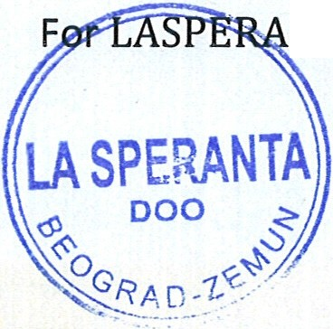

|  |  |
| --- | --- |
| I | **LASPERANTA 000**  Belaricka 26c, Zemun, PIB: 11003411  e-mail: [bbflex04@gmail.co](mailto:bbflex04@gmail.co) m  November 28, 2019    **KNOW ALL MEN BY THIS PRESENTS:**  THAT L  the Chief Executive of this Company, based on the Contract # LC.33/317 of 10/23/2019 accept unanimous the following **DECISION AUTHORIZATION :**  **Prof. George Angelow, PhD**  as individual and  President of **International Investment Council,** Washington, D.C., U.S.A.,  is assigned and authorized as our **TRUSTEE** and **CONTACT PERSON** to contact, represent and negotiate with creditors, export credit agencies, lenders, investors, exporters of capital goods and services and prospective partners for development of capital investment project in Croatia -  **SELF-SUPPORTING HALLS AND PREFABRICATED HOUSES**  - for our industrial development. All they are invited to communicate the above.  Giving and granting into my **Trustee** these power and authority to do and perform all and every act and thing whatsoever requisite, necessary or appropriate to be done as fully to all intends and purposes as I might or could do if personally present, hereby ratifying all that our company lawfully do, or to be done by virtue of these presents.  *I* do hereby confirm **To Whom It May Concern** that I shall ratify by either words or conduct any lawful and reasonable agreement within the scope hereinabove laid out or otherwise is follow­ ing therefrom.  N WITNESS WHEREOF, I, **Bosko Bezbradica,** CEO of the licensed entity, executed this Deed as of the day and month first above written  NTA Ltd. \  *(j '·*  **LASPERANTA,** Ltd., 26c, Zemun, Serbia  mob. +381-628 482 126, e-mail: [npegis@gmail.com](mailto:npegis@gmail.com) |
|  |  |