

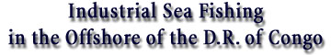
(Overview)

In 2000 our associate, T.D.C. Sprl, Kinshasa, Mr. Marcel Koultoumi, President, submitted to the Government of the D.R. Congo a project for industrial fishing in the offshore territory of the country, which has been approved later in the same year.

The permission license we obtained enable us to integrate an appropriate partner - a fishing company - into the project. Any manner of cooperation might be subject of discussion - from simple buy/sell commercial contract to a JV-company establishment for fishing and distribution of the draught.

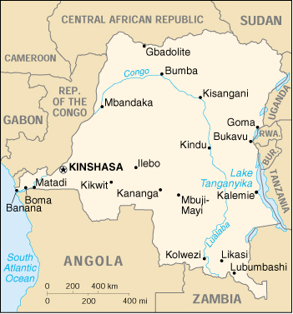
A comprehensive business plan and the concept of the development of the business will certainly depend on the number of the trawlers and other equipment that the associate company is able to involve. In any way, it is our understanding that we'll proceed with fridge-container to store the draught on the port of Matadi and forward it to Kin by railway, and the to rest parts of the country - by cargo airplanes. We project to build a shop for production of ice in Matadi.

The Draught.
Quantity: 40,000 T/year,
including:

- 2/3 of this quantity will be common sorts of fishes – maquereaux - $0.65 - $0.70 /kg.
- 1/3 - more expensive - capitaine, sole, daurade, thon, perche, baracuda, roujets; $2,5/kg.
- Another kind available are kreveti and langoustite, and calamari too.

Territory Water.
200 sea miles alongside the 21-miles (35-km) Congolese sea-shore and 36 miles inside of the down stream of the Congo river (there are fishes like malengua, mboto, and capitaine), where 500,000 tons of fish per year could be obtained.
Nowadays lesser than two percent of the fish consumption in the Congo is from local origin. The rest is from import. The prevailing kinds are from the sort of chinchar ($2.5/kg) and their like. The project stipulates production of salt and dried fishes, which are customary mush demanded, scars commodity, and are too expensive. It is recommended to be used insulated frig-containers (up to 450 pieces progressively increasing), which provide mobility and flexibility in use - either on the port and by transport.

Year end | Income from operations | Total costs | Marge brut d'autofinancement (M.B.A) | Earning after tax (EAT)
1 | 25,477,000 | 2,000,000 | 23,477,000 | 13,255,000
2 | 25,536,000 | 1,800,000 | 23,736,000 | 13,385,000
3 | 25,552,000 | 1,124,000 | 24,428,000 | 13,739,000
4 | 25,552,000 | 433,000 | 25,119,000 | 14,076,000
 |  |  | Total: | 54,455,000



For more information about how such relationship may be set up click the link below, and then find the topic "Program for Holding-out and Sustaining Congolese Jobs and Maintaining the People" in Section "Public & Non-government Organizations' Projects", and click the topic title. A short description of the program appears on the right frame. You may download a doc-file facility for further use. http://www.iic-london.co.uk/ctrl/projects/PROJECT ENTRY.htm
From Matadi to Mbuji Mayi, Kananga, Louboumbashi and Tshikapa.
All fish names are in French.

