

**BUSINESS PLAN**

__________________Information Memorandum

**SEA RESORT VILLAGE AND PORT** 

**Gozo**

**Executive Summary**

Contractor:   
International Investment Council

CONFIDENTIAL

Boston

September, 2015

executive summary

|  |
| --- |
| **CONTENTS AT A GLANCE** ☸ |

☸

**INFORMATION MEMORANDUM\***

CONFIDENTIAL NOTE

INTRODUCTION. Identification of the Developer and project location

PROJECT INFORMATION AND TECHNICAL MEMORANDUM

1. PROJECT SUMMARY 4
2. BRIEF DESCRIPTION

Type of Project

Status of the Project

Parties of the Transaction 6

Scope of the Project

Financial Package. Investment Total Costs

mAR

1. ****PROJECT DEFINITION 6

The upper two structural levels of the credit transaction are outside this financial model―credit and insurance

**🡐** **Level** **❹** Risk Assessment and Management, Online Control System ― *(16)*

**🡐** **Level** **❸** Decision Analyses, Profitability, top level of Developer’s decision making *(15)*

Financial modeling

* **Level** **❷** Investment Planning and Financial Modeling. Budget *(12)*

**🡐** **Level** **❶** Capital Goods and Services – import and local country costs; loan interest ― *(11)*

**🡐****Level** **⓿** Basic data, links to upper levels – Developer’s level, description of project definition

2. STRUCTURING OF THE CONTRACTUAL ARRANGEMENTS 20

3. CERTIFICATE 23

4. PHOTO AND DRAWING GALLERY *(attachment)* 22

5. LIST OF ENCLOSURES 28

☸

**__________________**

**\***This Summary is generally assumed to be used online. TheURL links on the electronic copy facilitate following the content when read. References to external sources are intended for people who are using assistive technologies, and for non-financial experts—administrators, business managers, entrepreneurs, translators.

contact information

*e*mail: boston@iic-london.co.uk about busPlan: ph. +359-888-69 07 96 – Prof. Dr. George Angelow, Fin. Advisor

**CONFIDENTIAL NOTE**

This Business Plan (the present EXECUTIVE SUMMARY, Excel-based ***Pro-forma*** ***Capital-Budget­ing****,* Risk Assessment Program, the enclosed contracts, commercial offers, certificates and other papers and instruments) contains commercial and business secrets, and is **confidential and/or privileged**.

Electronic copies are password secured. Access and/or download are allowed for authorized recipient only. It is not for re-direction. Hard copies of this Feasibility Study are intended for named recipients only.

The information collected herein is based on intellectual property created by U.S. Company and must be held confidential subject to the Freedom of Information Act in Title 5, United States Code, Section 552, Privacy Act of 1974 (5 U.S.C. 552a), except as required to be disclosed pursuant to applicable law.

Copyright 2012, International Investment Council, Washington D.C. and Prof. George Angelow, President

*This is a Feasibility Study. It does not imply an offering of securities.*

*Prepared by International Investment Council, Ltd, Sofia, by  
courtesy of International Investment Council, Washington, D.C.*

**INTRODUCTION 🞁**

**Name: KalaMarina** (Project)

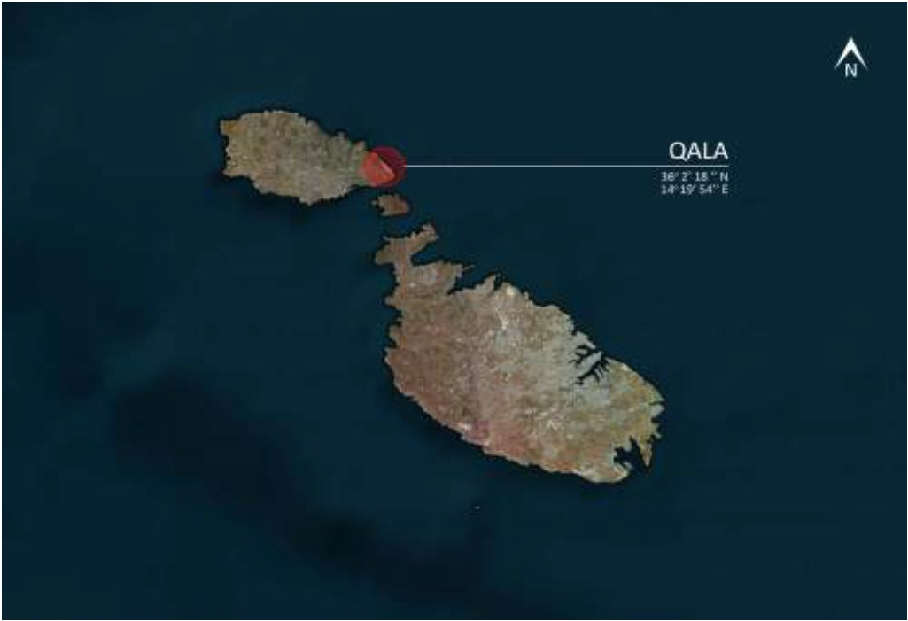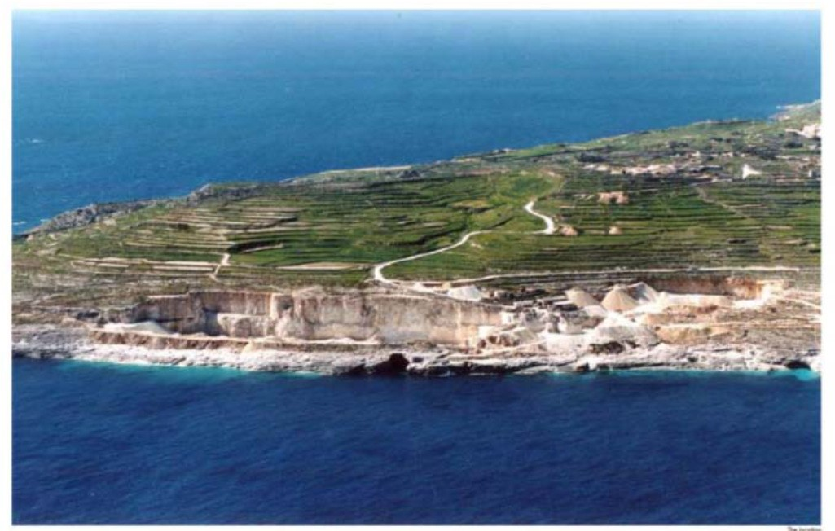

**Applicant:** Kala Marina, 40 Shipka St., Lom 3600, District of Montana, Malta.

**Subject:** Capital investment in see resort with port

**Value:** € 243,100,000.-[1] for [project financing](http://en.wikipedia.org/wiki/Project_finance).

**Term:** 61/2 years; 18 month grace period.

**Collateral:** Corporate equity bonds.

**Indicators:** NPV € 386,772.-; IRR 7.51%, in   
hurdle rate selected 7.5%.

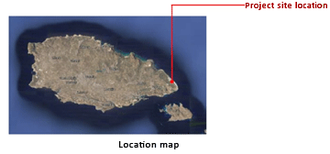**Location:** South-east coast of Gozo within an exhausted quarry.

This area that bears reference to a small cave in the area that will be retained in its original form. The currently inaccessible coast line will be returned for public use. On project completion, bus coaches carrying cruise-line passengers as well as public transport will also use this road to ensure minimum disturbance to this quaint village.

Developer / Project Company (PC) is Kala Marina**[2]**

. . . . . . . . . . . .,Malta

Shareholders

. . . . . . .

. . . . . . .

. . . . . . .

. . . . . . .

**PROJECT INFORMATION AND TECHNICAL MEMORANDUM**[3]

1. PROJECT SUMMARY  ⮉

1.1 BRIEF DESCRIPTION

The rules of operation of the formal system on Level 1 [Worksheet Cap.Goods ] are determined by the rules of the upper Level 2 [Worksheet Budget ], which in turn are defined by the functional rules of Level 3 [Worksheet Bayes]. The meta-rules of top-level cannot be changed because there is not a higher level over it, which has rules that specify how to modify these rules. This is the principle of creating the model, which significantly reduces the probability of mistakes in the design of the model and in the operation with it during the loan life.

* Level Baseline data for pre-design [Worksheet Intro]
* *Type of Project* **Kala Mariner** – Sea Resort and Port
* Village of 75 villas, 300 m2 build-up area each with private pool
* Cruise Liner Terminal – will accommodate liners up to 200 miters in length

|  |  |
| --- | --- |
| * Apartments: 57,500 m2 terraced apartments all enjoying open sea views and landscaped terraces: A – 180 m2 3 bedroomed  B – 108 m2 2 bedroomed  C – 266 m2 duplex  D – 126 m2 2 bedroomed  E – 86 m2 1 bedroomed | * Leisure:   150-room Five star Boutique Hotel with   * + - * Recreational facilities       * Food and beverages outlets       * Open spaces for public access and recreation       * Beach club and lido |

* Commercial Center: 17,000 m2 dedicated to commercial outlets; Yacht Chandlery Yacht; *and* Charter and Brokerage

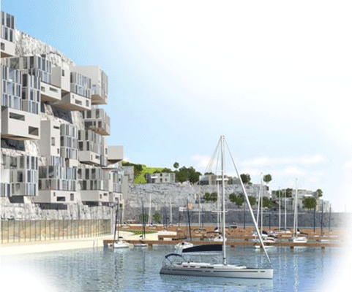

VIEWS OF ARCHITECTURAL DESIGN

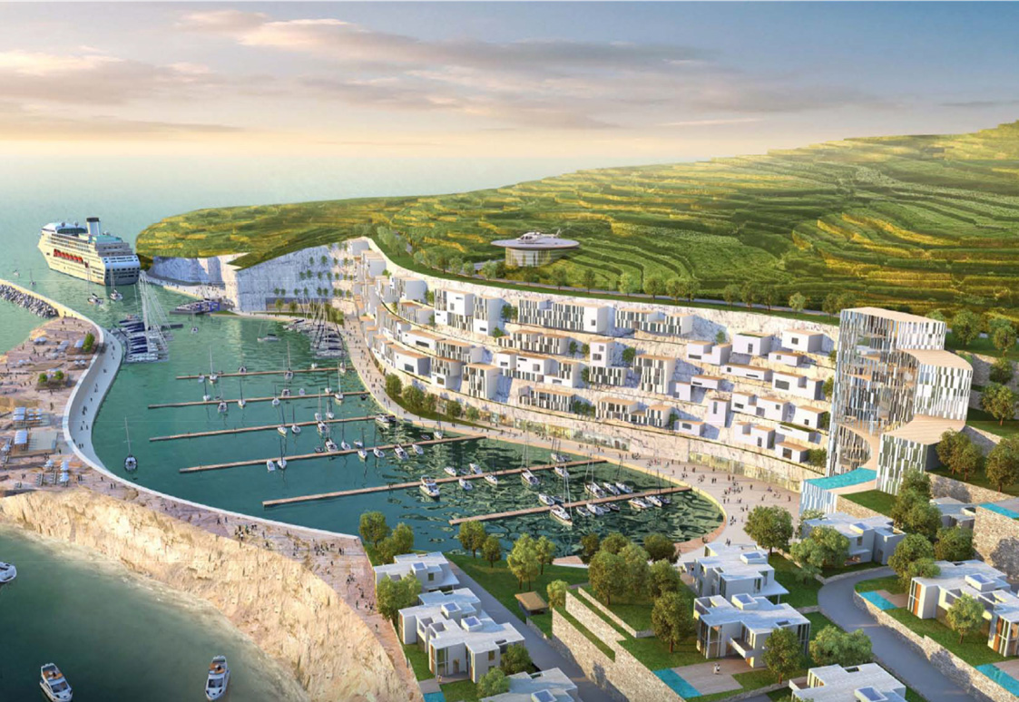

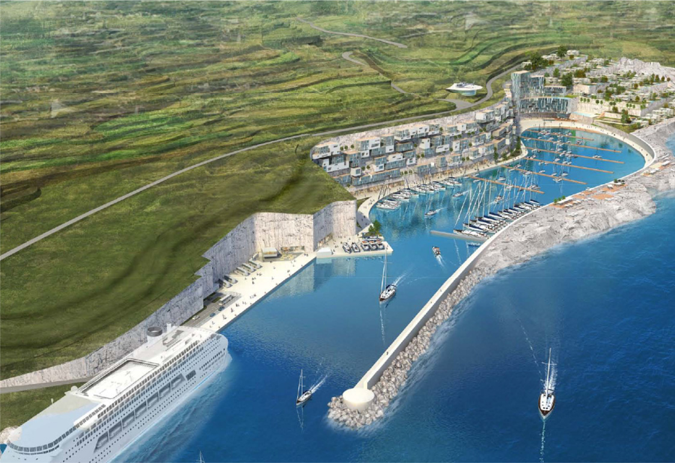

-**PREDESIGN BACKGROUND**-

-**initial parameters on the base level:**

* *Status of the Project*

This is full recourse [capital project](http://www.businessdictionary.com/definition/capital-project.html). The financial model is developed for [project financing](http://www.businessdictionary.com/definition/project-financing.html?q=project%20financing) by state credit export agencies, investors and equity partners of the project company. Its purpose general is to conclude a [concept design review](http://www.businessdictionary.com/definition/concept-design-review-CDR.html) ([CDR](http://www.businessdictionary.com/definition/concept-design-review-CDR.html" \o "To biz professional dictionary)) through an optimal size of capital investment in a sea resort village and port. This financial model is developed (i) to be presented to a credit institution for funding, and (ii) for monitoring and operational control during the loan life. It has a hierarchical structure with four levels.

Proponent currently has contractual right to excavate the site and is willing to give up this right in return for development concession.

Government of Malta intends to transfer sixty-five year concession of the land to the PC for development of the project. Buyers of residences will have the right to convert to a perpetual ownership by paying a nominal amount (which is normally set at 1 years’ ground rent).

Operators of cruise liner terminal, yacht marina, hotel and commercial center provided letters of intent to . . . do what? . . . **[4]**

The presentation includes:

* This [Information Memorandum](http://www.businessdictionary.com/definition/information-memorandum.html) (Business Plan – Executive Summary, this document), where the information memorandum provides a verbal detailed description of the Financial Model so that an auditor making due diligence can gain full perception of the business venture with its profitability evaluation, risks assessment for use of all participants in the credit transaction with full control of its performance and further management. Part of the Summary is focused on a guide for easy operation with the Excel file with the financial model and software and correct understanding of the contents of the business plan.
* Functional Model of [Capital-budgeting](http://www.businessdictionary.com/definition/capital-budgeting.html)—[Cash-flow Pro-forma](http://www.businessdictionary.com/definition/cash-flow-forecast.html)**[5]**

— Pre-design background in figures [Worksheet  **Intro** ];

— Capital goods and services with their prices [Worksheet  **Cap. Goods** ];

— Sales, Costs, Cash-flows, Measuring Profitability and Pay-back methods applied, Sensitivity Analysis, and graphical representations of most important parameters of the Financial Model [Worksheet  **Budget** ];

— Personnel and salaries on payroll [Worksheet  **Staff** ];

— Decision Analysis of posterior probabilities of events affecting the most important factor with impact over the cash inflow for risk management in operation [Worksheet **.Bayes** ].

* Risk Assessment and Management[6] with Manual[7]of demo version and Description. It is an Excel file [](http://www.iic-london.co.uk/ctrl/projects/greenhouse/RiskAaaessment_Valister.xlsm) with the financial model and software. It is provided in customized version with actual results of the assessment of eight risk factors and their impact over the business venture. A brief description facilitate a fast but not complete [](http://www.iic-london.co.uk/ctrl/projects/greenhouse/RA_Valister.xps)understanding of pre-design study[8].

This Executive Summary of the Business Plan is a formal document that fleshes out the details of a profitable investment and its project financing. Its format affords the philosophy of the project—developer Work Breakdown Structure ([WBS](http://www.businessdictionary.com/definition/work-breakdown-structure-WBS.html)) —location of the village, communicability, marketable prices of rents during three-season annual periods.

When the Excel file with the financial model and software is for first time opened, a part of the data there presented, may influence your correct understanding of the whole model. That is why this data is hidden under the picture showing what the greenhouse may look like. Once you complete the review of the model, you can click the picture to see this data.

* *Parties of the Transaction* [⮉](#CONTENT" \o "back to CONTENT)

****Developer.** It is the Project Company**[9]** and the [Project Owner](http://www.businessdictionary.com/definition/project-owner.html), also Borrower as a party to the credit agreements who will develop the project on its own land.

Acquisition of land and real estates in anyone of the EU associate country is a privilege of the EU. Foreign Investor in Malta may use the assistance and protection, if requires, of the Government Export Credit Agency (ECA) if such an ECA supports financing the project.

**Developer’s Advisor**. A local country business entity**[10]** which would make [concept engineering](http://www.businessdictionary.com/definition/concept-engineering.html?q=concept%20engineering) and a part of risk assessment on [concept design](http://www.businessdictionary.com/definition/conceptual-design.html) stage of the project and the whole program in the specific business environment (conditional option).

** Manufacturer** of timber frame / log homes Mediterranean design which exporter and turnkey supplier**[11]** to the final destination.⮛

* **Offtake purchasers** – vacationers and buyers from around the world but statistically and traditionally the most likely are from Russia, Ukraine, Bulgaria and some of North European countries and Middle East. Local tourist agency and real estate companies will manage the accommodations and selling the properties.

**Lenders**.**[12]** They are (i) a U.S. Bank that will extend the Loan “A” secured by Ex-Im Bank guarantee and other financial institution that will credit Loan B under marketable conditions and will disburse them to the U.S. Manufacturers; *and* (ii) a foreign, local Bank. Ex-Im Bank guarantees the repayment of the foreign bank's obligations.

* **Municipality public or accredited companies** providing infrastructure facilities like connec­tions to power grid, water supply and sewerage system.**[13]**
* *Motivation and Scope of the Financial Model (FM)*

The KalaMarina project is designed to transform a site that is currently used as a stone quarry into a landmark destination in Gozo. It will enhance and embellish an area, otherwise considered an environmental eyesore, where there is currently significant noise and dust pollution. Landscaping will be a dominant feature of the project to set the tone for the establishment of a high-end destination in a tranquil and serene environment.

The Developer and its proponents have engaged a number of international firms experienced in the construction and operation of cruise liner terminals and yacht marinas, residence properties and commercial outlets. They bring to the project vast years of experience in planning, development, execution and operation of projects of this nature.

This project will enhance and embellish an area, otherwise considered an environmental eyesore, where there is currently significant noise and dust pollution. Landscaping will be a dominant feature of the project to set the tone for the establishment of a high-end destination in a tranquil and serene environment. The project will consist of a cruise liner terminal, a yacht marina, low rise residences and hanging apartments, commercial outlets, a boutique hotel and spa and open recreational spaces for public use.

The multiplier effect of this project will have a positive impact on the Gozitan economy curtailing the drain of youth seeking employment opportunities on the mainland.

* *Financial Document Package* – contains full set of documents, licenses, permits and other papers and certificates as the local country regulations so requires. The financial model contains two options for the Investor to select―two steps development, with first stage Mariner 1 or to go directly to Mariner 2 project. Each includes two sets of documents which relate to two types investment capital, originating as follows:
* Loan A – from a lender, credit bank, secured by Ex-Im Bank of the United States in an amount equal to 85 percent of the U.S. supply contract(s) plus up to 30 percent of it for host country local costs, *and*
* Loan B – from either Developer’s own participation or a local commercial bank loan collateralized by developer’s own assets or by sponsor, but entirely independent from the assets earned by Loan A.
* *The* *Market*



1.2 PROJECT DEFINITION [](http://www.businessdictionary.com/definition/project-definition.html) ⮉

*Project Analyses*

This project is an extract from a software package part of financial model for capital investment and operational online control. The financial model is supposed to interpret the description of the business such as it is – in figures and formal function dependences, carrying a maximum isomorphism between them. It is up build in hierarchical structure (see below) which prevents of errors and omissions following the professional qualifications of the experts and the designers of the financial model. Each level of this structure is a [formal system](http://en.wikipedia.org/wiki/Formal_system) with rules, functions and links, representing information to the upper stratification level, where the rules remain valid. And thus to the top level of the model wherefrom through a feedback is controlled the whole system for successfully high yield operating with high value of profitability, and the risk management that form the minimal expenses for its achievement.

All materials, textual and tabular, are saturated with images and various colors – solid and fill effects. Painting materials are perceived 60,000 times faster than the written.

Thus is defined the business plan of the project presented below in its two phases of development.

① . . . . . . . . . 1 – 8 homes

1. To buy 9,378 ft2 10,000 m2 land for this stage only
2. To buy 32,000 m2 land for both stages

② . . . . . . . . – 24 homes

The structure of the debts which are to be amortized is as follows [Worksheet  **Budget** ]:

**①A** **①B** **②**

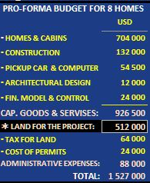 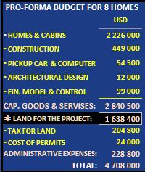 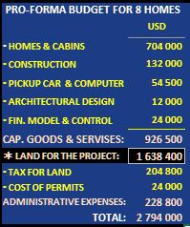

* Collateral. Developer is a newly established, not creditworthy company. The required guarantee of Loan A is in form of corporate Promissory Note (PN), issued by Developer and [confirmed](http://www.businessdictionary.com/definition/confirmation.html?q=confirmation)/guaranteed by the sponsor – a friendly creditworthy company. The Developer bonds for the benefit of the PN’s guarantor.

This layer is on basic stratification level *(specifically those, indicated the darkest blue background)*, and the market price situation.

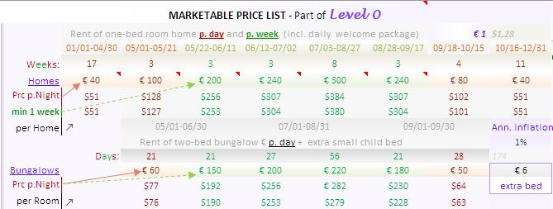

Row 5 ⮞

Row 11 ⮞

*Sale Prices* [on top of Worksheet [Budget](http://www.iic-london.co.uk/Mariner/Property/Mariner1-2.xlsm" \l "Budget!H1)]

MARKET PRICE LIST is to reflect market based pricing of rent both the family homes per week and bedrooms in bungalows per day for 2012 and 2013 fool year data. In Section “Marketable Price List” on the top of [s 5 and 11 in Euro] are used for the purpose of budgeting cash-flows pessimistic price forecast of accommodation services in the log homes.



* Level Capital Goods and Services [Worksheet Cap.Goods ].  ⮉

This layer contains the rules of investment of the borrowed funds in the grace period. It is 12-month long, two 6-month budget periods. In this period the foundations should be ready, homes supplied, assembled, and the electricity, plumb and site work completed. The last four months of the grace period are for trial operation of the resort.

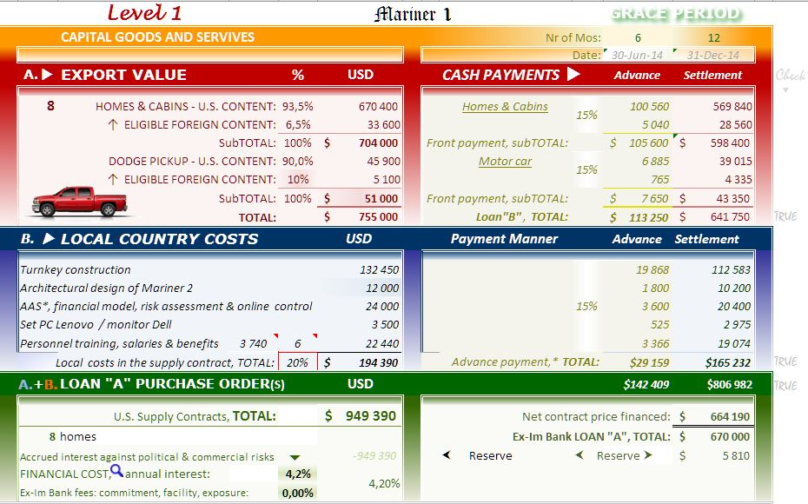

The above excerpt refers to first stage, Kala Marina 1, Option **①B**.

Capital expenditures are divided into two groups – for import and local country costs.

* The estimated costs of 15% of the U.S. export are due to the investor from own funds of, in not available, to be borrowed from a local commercial bank, Loan “B”.
* *LOCAL COUNTRY COSTS* pro-forma budgeting presents services of critical importance.
* FINANCIAL COST and commitment fees are provisional, and will be fixed at the appropriate stage of development of the project.

If you like to change you approach to development of the project, return to Level 0, [Worksheet  **Intro** ] and change the selection with Option **①A** or Option **②**.



* Level Investment Planning and Financial Modeling Worksheet Budget. ⮉

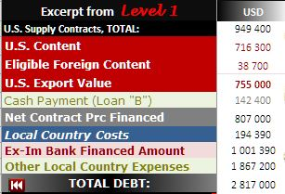Exhibit A is a transition of basic information from the lower levels. They are carried over the same practices and formal functional dependencies.

**Budget**. Section CASH FLOW. Sales and CostsPro-forma

**A** layerthat receives information from Level 1 of the model which exercise the same practice and formal functional dependencies, and the investment totals $949,400.- [Cell B17], $807,000.-; [Cell B18] Loan “A” and $142,400.- [Cell B19] Loan “B” for 12-month grace period. They form the cash flows for the loan life of 14 periods (7 years) – for **Option** **①B**.

* *Anticipated Project Time Frame*

The Project [time frame](http://www.businessdictionary.com/definition/time-frame.html?q=time%20frame) covers Loan “A” repayment term. It is fixed on 7 years, (4 of six-month periods, following the [concept engineering](http://www.businessdictionary.com/definition/concept-engineering.html?q=concept%20engineering).

* *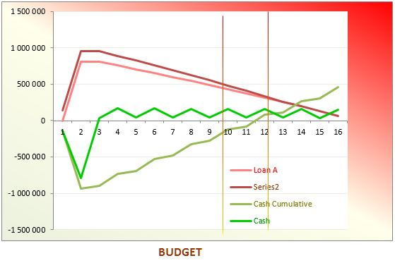Construction of Graphs*

The results from budgeting are plotted—functions of total balance liabilities, cash flow, operating cash cumulative.

Themodeling system will build graphically the real indicators during the loan life for visual comparison with the budgeted for monitoring and management of the Company.



MEASURING PROFITABILITY MODEL AND RISK ASSESSMENT—both are the core part of the Business Plan. The Items of Section 1 herein above was to provide data for this analyses and for the supervisor making due diligence of the Project.

* *Measuring* *Profitability Model* Worksheet Budget

**T**he [Payback Period Method](http://www.businessdictionary.com/definition/payback-period-method.html) [see Exhibit B, Cell G61:H61] shrinks it to 4 years and 9 months for **Option** **①B** (5 years and 7 months for **Option ②**). It has the following advantages:

1. 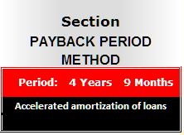Payback period is very simple to calculate.
2. It can be a measure of risk inherent in a project. Since cash flows that occur later in a project's life are considered more uncertain, payback period provides an indication of how certain the project cash inflows are.
3. For companies facing liquidity problems, it provides a good ranking of projects that would return money early.

Disadvantage of payback period is that it does not take into account the [time value of money](http://accountingexplained.com/related/tvm/) which is a serious drawback since it can lead to wrong decisions. A variation of payback method that attempts to remove this drawback is called [discounted payback period](http://accountingexplained.com/managerial/capital-budgeting/discounted-payback-period) method.

* *Measuring* *Profitability*

Exhibit B is Discount Cash-Flow Model where Section MEASURING PROFITABILITY provides clear picture what is the value of the money involved in the project. Note that after repayment of the loan(s) the investor remains except with the cash (see the Cash Cumulative, Row 84 and the Graph “BUDGET” below) but with long-term assets – the land and homes on it plus the accumulated depreciations on them. You will find details about this in Chapter 2, FINANCIAL ANALYSES AND MODELING, below.

* *Product Demand Forecast with Assumptions*

**T**he focus of the analyses is on the premier asset, cash. The *time value of money* of this analyses shows that the purchase of these assets earns significant revenue and the cash received. Its excess over the cash paid for the costs associated with this investment is computed on project NCFs [Row 50]. Discounted Cash Flow Approach to capital budgeting computes a **positive NPV**[14][Cell B62]using 12% discount rate, [Cell B60], even in reducing the *Occupation(s)* option[Section “SENSITIVITY ANALYSIS”]*.* This NPV indicates that the investment should be purchased.

Loan Life Coverage Ratio (LLCR) [Cell D61] in a Reasonably Expected Level of Occupancy, the set values of variables Simulations A**1** and A**2** activities. A LLCR equal to 39% means that the borrower is able to repay a loan that is unresolved.

**W**ith the Option ①**B**, two-stage development, Kala Marina 1 first, the Project Company, can expect to earn at least **24%** (this is pessimistic forecast) by investing in the project [Worksheet [Budget](http://www.iic-london.co.uk/Mariner/Property/Mariner1-2.xlsm" \l "Budget!B62) Cell B62]. This is IRR (Internal Rate of Return) of the project – another discounted cash flow model for measuring the profitability (that makes net present value equal to zero) [click the Button “**Check IRR**”]. Managers would invest in Kala Marina 1 project because these cash-flows could be reinvested in the next stage, Kala Marina 2, with this percentage of IRR, which exceeds the 12% Discount (hurdle) Rate [Cell B60], and creditors’ auditors of the due diligence would approve it.

**M**odified Internal Rate of Return ([MIRR](http://www.investopedia.com/terms/m/mirr.asp" \l "axzz2FhEG8d6y" \o "To Investopedia)) is not computed because it cannot be validly used to rank-order projects of different sizes, as Kala Marina program assumes, because the next larger projects with a smaller MIRR may have a higher present value.

* *Analysis of Funding Sources*

**L**ocal host country banks and “High Street” branches of EU banks are not accustomed to assessing real estate projects and, as a result, decline interest without due consideration if there is not available a high-value collateral, even the business plan is extremely well presented. Few sophisticated in EU programs and project financing local banks may finance the required 15% own participation in the loan transaction, as well as some other associated to the project costs, but only after its Ex-Im Bank was first approved and secure the project. This is a clear articulation of the need for Ex-Im Bank coverage.

* *Bonding*

**L**ender of Loan “B” may require bonding to secure the performance of the contractor, involved in construction. The bonds will typically be payment obligations (on-demand or subject to pre-agreed conditions) in favor of the project company. The Lender will take an assignment over the bond to ensure that any call on the bond results in payment to a bank account which they control. The objectives of bonding may also be achieved by guarantees or standby letters of credit provided by the Bank.



* Level Bayes. Decision Analyses [Worksheet [Bayes](http://www.iic-london.co.uk/Mariner/Property/Mariner1-2.xlsm#Budget!B59)]  ⮉

**S**ensitivity analyses is required attribute of the business plan of investment project, especially whit NPV positive but close to zero. It is due to the posterior probabilities of one or more events might happen on the market, and that to reflect negative over the cash inflow. This would increase the Default Risk (d) (of non-payment of some loan installments). For this project it is applicable only to the outlined too sensitive problem depending on quality of operation of the two contracted travel agencies during the periods called **in**active seasons.

**T**he options of rent homes are presented in Section “**SENSITIVITY ANALYSIS**" [Exhibit C, Worksheet Budget **.** It is assumed that in the active seasons the occupation is 100%**+** as follows:

* 100% is the occupation of two-bedroom homes by one family – one bedrooms
* (**+**) means option of occupation all (the two) bedrooms by two families or one with at children; the occupation of the second bedroom costs 20% extra charge.

**A** study of posterior probability events of interest is the sensitivity parameter *Occupation* during only of the **in**active seasons. The following activities of both travel agencies are a part of the formal system of this level. Percentage reducing the number of visitors during inactive season with bookings from each agency defers. In this pre-design analytic period it is simulated by the Spin Buttons (ActiveX Control) in the field of Exhibit C.

**I**t is supposed two agents committed to book vacationers where each of them serves the resort Operator’s need performing its obligation *Bad* in certain percentage (excluding the intensively active period 07/03-08/27 and the inactive periods). 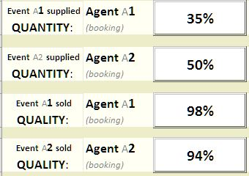The quality of services of both agents is taken into account too in Worksheet .Bayes―Agent A**1** managed to fill with tourists the two rooms of the two-bedroom homes in 98% of the cases (Percentage ***Good*** event), while the other, Agent A**2**, failed to assure complete such occupation with 6% of the cases (***Bad*** event). The overall probability to happen ***Bad*** event is **3.70** [Cell P21]. This ratio decreases proportionally the value of Sales Homes [Worksheet Budget , Cell P21]. This values are completed online automatically in operation by the control system.

**F**or management of “d” in operation the model allows you to predicate virtually POSTERIOR PROBABILITIES OF TWO EVENTS [Worksheet Bayes ] relevant to occupation in that time. The reduced occupation automatically re-computes the revenue in Row 20, “Sales”, [Worksheet .Budget]. The Operator can update currently the information about the posterior probabilities. This is the best way of managing the default and operational risk factors on time and to mitigate them significantly.



* Level Risk Assessment  ⮉

SUMMARY OF RISKS

[](http://www.iic-london.co.uk/ctrl/practice/risk/RM_Description.docx)**☼** Worksheet Bayes is part of **RISK ASSESSMENT AND MANAGEMENT PROGRAM** which, in turn, is part of the financial package for application for financing the project. It will be delivered under the Investment AAS*[15]* Agreement**[16]**.

Comparison of the prices applied in the project with other similar rental sites, downloaded from Internet of the average general, shows the following. [See Rental Rate, RR ⇩]

* + - 11 percent higher average prices for one year on the market for similar offers;
    - Significant positive diffidence in the quality between the American family log homes and the offered homes; [[See the Web-presentation](http://bg.pensionhotel.com/chiza-nisaki-chata-nisaki-grecija-chizi-a02112111.html#map_canvas)];
    - Locations of the homes, we compare with Mariner village, are very far, several miles, from the beach, which cannot not be compensated by artificial 72-feet pools in the yard**;**
    - Both options compared propose similar “welcome packages“(bottle of quality wine, tee, sugar, honey, bottles mitral water, plus full time free Internet and TV cable access.

The above characteristics refer to all said cottages published on one of the most visited in the region tour-operator’s site.

Theoretically, this is an attempt for verbal description of the semantic features of architectural project and its connections with other diffuse dependencies – credit resource, duration of the seasonable clusters, respective marketable pricing of each of them, cash-flows, analyses and their syntaxes description. For the financial model terminological it is an informal system which needs specific rules to create the baseline data for pre-design. The actualization of this layer is possible, but once fixed it must not be changed or to be created whatsoever on it until you operate with the selected option. When you desire to study the content of the mode, your attention has to be focused on next higher levels, and they are entirely built up by symbols – figures, formulas and rules which show how to modify those rules just like [formal systems](http://en.wikipedia.org/wiki/Formal_system) of higher level.

Here are treated primarily financial risk factors (that an actual return on an investment will be lower than the [expected return](http://www.investorwords.com/1840/expected_return.html)). Risk assessment of the project is made with specific version of our **RISK ASSESSMENT AND MANAGEMENT PROGRAM**,[](http://www.iic-london.co.uk/ctrl/practice/risk/RM_Description.docx) which is a part of the financial package for analyses and loan application. Two groups of risks analyses are specific to this project following negative occurrence caused by:

* 1. **Basis risk:** not exists by nature of the transaction.
  2. **Lenders’**[**capital risk:**](http://www.businessdictionary.com/definition/capital-risk.html) Un-recovered loan installment(s) will be prevented by strict performance and oversight of the Action Plan (see Item 9 below) by Financial Advisor (IIC-Boston).
  3. **Delivery risk:** not exists by the nature of this transaction.
  4. [**Economic risk**](http://www.businessdictionary.com/definition/economic-risk.html)**:** Greece is currently in very serious economic crisis. The tourism is almost the only field there that cannot suffer from the negative occurrence that is caused by internal [vulnerabilities](http://www.businessdictionary.com/definition/vulnerability.html)because the revenue depends on external sources. In contrary, the prices of internal reasons of expenditures like the purchase prices of the land and of the services drop down. The only “negative” impact is the recently entered into practice tax for corroboration of the national economy expressed in single payment of $1.20 per sq. feet (€20 per sq. m.) new built area.
  5. [**Exchange rate risk:**](http://www.businessdictionary.com/definition/exchange-rate-risk.html) not exists.
  6. [**Interest rate risk:**](http://www.businessdictionary.com/definition/interest-rate-risk.html) not exist by nature of the transaction and lender.
  7. [**Liquidity risk**](http://www.businessdictionary.com/definition/liquidity-risk.html)**:** nil; the Borrower is liquid during the repayment term [Section *Sensitivity Analyses* by the *spin button* in the *ActiveX control*].
  8. [**Operational risk**](http://www.businessdictionary.com/definition/operating-risk.html)**:** low level with option to be significantly mitigated during operation. Online Cash-Flow Control System**[17]** (OCFCS), which is a part of the financial package for loan application, will help Investor to operate transparently the business for the lender and to escape bad events that might increase the default risk. Greece is traditionally a preferred tourist destination. It is not expected loss of demand of this service or crash in training of managerial staff.
  9. **Political risk:** Greece is a friendly country to the Unites States; in Loan “B” this risk factor may affect the price (interest only) of the bank guarantee that a local bank will issue based of its customary practice and market price.
  10. [**Refinancing risk:**](http://www.businessdictionary.com/definition/refinancing-risk.html) no maturing liabilities that might need refinancing.
  11. [**Reinvestment risk:**](http://www.businessdictionary.com/definition/reinvestment-risk.html) reinvestment is possible and recommended but this project does not require mandatory interest-earning assets (loans).
  12. [**Cost overrun risk**](http://www.businessdictionary.com/definition/cost-overrun.html):There are negligible operating costs of small staff. However, there is some operating risk that is out of Operator’s control.

(See a provisional application of the software program below)

Brief Description of the Product. This is a quite separate, standalone product. Making full and complete assessment is not subject of this stage of development of the project.

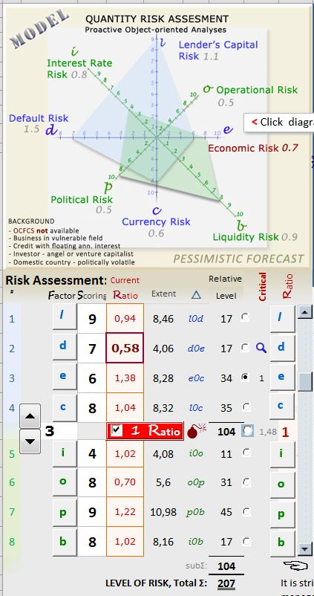An expert of the project’s investment advisor made QUANTITY ASSESSMENT OF THE FINANCIAL RISK of the investment project.

The applied approach is based on general accepted criteria for quantity assessment in percentage of the adequacy on the scale up to 10, applied and processed by the Advisor’s software product. The Program is based on Excel-file of Microsoft Office 2007 package of Windows 7 with macros for faster operation and algorithm of BA-program language.It is widely used in the U.S. and Britain after the failure of conventional products for risk assessment before the mortgage financial meltdown in 2008. A Demo-Version is enclosed,  an excerpt of the program, which can make partial interpretations; Handbook  for use and Presentation of the product for quantitative risk assessment before investment and subsequent control over the debt period. Sensitive analysis are focused primarily (but not exclusively) on two risk factors, (d) and (o) of particular importance for financing and insurance institutions and, of course, to conceptually associated investor / borrower.

The figure above presents the introductory segment of the matrix of expertise in mathematical model of geometric figures, proportional to the size of the risk factors and the extent of its impact on the investment Project.

Risk Factors

AssessmentRateLevel

Number of assessors of statistic assessment

on 0-10 of impactof Factor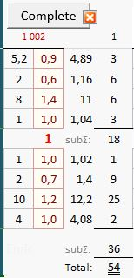

Button to enter of data of the assessor with **code index 1 002**

**Coefficients** < 1 indexing subsequent strong impact of the risk management.

Risk assessment

Value of the Factor multiplied the Rate of impact – this is the real level of this risk in the business environment.

Risk assessment with its impact over the business was made by one only external for the Developer expert. Shortly, the result suggests that development of the project in the two stages, hereinabove on Page 7 and then down to, indicated as Option **①A** or Option **②**, is recommended.

Area of △ *p0b* = 12.2 x 4.08 / 2 rounded to 25 (see the figure)

Total area - **Total assessment**



Risk Management ⮉

**W**hen a user of Risk Assessment software product (NOT AVAILABLE here) round out operation, it arises the question how to utilize the results in improvement of work and it optimization. Then return to your reasoning―two layers down to Level 4.

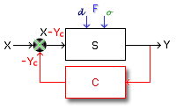**T**he prior probability estimates for specific event of interest – those are special reports sources from the accounting as the beginning of drop down income stream from for one seasonal period price compared to the corresponding in the model one (in Level 0, on the top of Worksheet .Budget . The revised probabilities for such events, herein referred to as posterior probabilities, help the formal system to provide means for computing these posterior probabilities as described below. This is the strongest approach for to operational management of the revenues through any seasonal period cash inflow. As a draft estimate it is prescriptive only, showing the degree of impact of possible *bad* events over the subject of automatic control “S”, cash inflow (usually denoted by “F”) – when some agent does not achieve the expected results from his sales, measured by the income stream “Y” compared with the available bedrooms and reasonable occupation for this period. This is in the full sense of the Economic Control Systems terminology, an application of its basic function a Feedback Control System of cash flow. The separate cash flows for every period (herein denoted by “X”) is the input data of the system.

The prior probabilities of so called *bad* events of interests “F”, generated when modeling by the Scroll Bars (ActiveX Control) in Exhibit C and in operation through online information about operation from accounting department, reduce the output “Y” cash inflow. Its values for every seasonal period are computed through the Bayes theorem (herein denoted by “C”). The results (-Yc) are summarized with the input and the difference of the amount (X-Yc) shall be submitted to **the input of the system** “S” (which is correction of Level 2) for performance. The information flow of data from Level 2 is transmitted to Level 3 and up to Level 6 wherefrom imperative instructions are directed again back to Level 2 for control.

The OCFCS periodically (weekly, monthly, etc.) makes monitoring of the financial accounts, primary documents and returns, and ex-changes the relevant figures in an active Excel-file, maintaining on the IIC’s Website. The graphical representation of the planned and implemented indicators presents the difference (if any) and allows the user to monitor the assumed financial position of the debtor online as well remotely from the program to require those primary accounting documents, which are due the discovered difference. This option significantly increases the credit worthiness of the project company.

******Continuous monitoring of the plant by *PC-Microsoft VBA Based Online Remote Cash-flow & Monitoring Control Peripheral System* for secure and warranty of non-repayment the loans. The system is based on software product on MicrosoftExcel Visual Basic code platform encompassing the Functional Model of Capital Budgeting Project as continuation of Investment Advisory Service. Monitoring of all system parameters including cash-flow online control *and* secured priority access are of significant importance for the lenders, insurances’ officers and sponsors. It will be made through the U.S. located servers of the [executive sponsor](http://www.businessdictionary.com/definition/project-sponsor.html), [IIC](http://www.iic-london.co.uk/)W,[](http://www.iic-london.co.uk/) Boston, Mass.



2 STRUCTURING OF THE CONTRACTUAL ARRANGEMENTS ⮉

INTRODUCTION

It was recommended that the Developer, planning a family resort village project, seeks professional advice at an early stage to determine how to structure the first project of a program and to arrange the financing. Financial and legal advisor, does not depend on the developer’s own level of expertise.

As often happens, in such early stages of development the project, Advisor will work largely on a contingency basis(ie, no project, no - or a very much reduced - fee). Hence, the initial costs to the Developer are relatively and absolutely modest; if the project does proceed, the higher costs associated with Advisors area affiliates will be more than recovered, and it will be money well spent.⮛

PROJECT CONTRACTS

The commercial contracts form the basis of the security structure which creates the cash flows and hence underpins financial opportunities including, but not limited to, the project financing. For this sea resort village project, the principal contracts are:

* *Turnkey Construction Contract:*Engineering, Procurement, and Construction Agree­ment (with subcontractor) on a fixed price basis).

The Turnkey Contractor will, in effect, guarantee the performance of local subcontractors and equipment suppliers and assume “single point” responsibility for the overall construction of the Project.

Draft turnkey construction contract and description of sources of possible cost increases and delays during construction, including detailed description of liquidated damage provisions and performance bond requirements.

This experienced and credible Turnkey Contractor is the key to the development of a project as lenders will be placing significant reliance on the contract to ensure that the project is completed on time and from a technical perspective, performs as expected. Lenders may require bonding or external guarantees to support the obligations of the Turnkey Contractor (e.g. to pay liquidated damages). Risk allocation, insurance, binding, and warranties will be due to the Contractor.

* *Investment* *AAS* ([Advisory and Assistance Services](http://www.businessdictionary.com/definition/advisory-and-assistance-services.html)) [Master Agreement,](http://www.businessdictionary.com/definition/master-agreement.html) incl. financial pack­age project as follows:

(i) [Professional Service](http://www.businessdictionary.com/definition/professional-services-contract.html) Cost Plus Fixed Fee (CPFF) Contract,**[18]** a full recourse [arm’s length transaction](http://www.investorwords.com/254/arms_length_transaction.html)  *and*

(iii) Cash-flow & Monitoring Online Control Agreement**[19]** – a Remote Control System Operation Contract (CSO-Contract) 

System operation of this first project of Program is relatively straightforward (although still important).

* *Land Purchase Contract***[20]**
* *Service Agreement for Permits and Regulations.***[21]** Provides defend of Interests. IICAthens through DC-L SP as a legal entity commits [Invest in Greece Agency](http://www.investingreece.gov.gr/) S.A., [](http://www.investingreece.gov.gr/) sole state owner – the sovereign is represented by Ministry of Economy, Greece; responsible for the implementation of "Acceleration and transparency of implementation of Strategic Investments" law.⮛
* *Hotel Booking Service Contract***[22]** with Alma Holidays Ltd. [](http://www.almaholidays.net/), a huge regional hotel booking agency specialized in making travel arrangements for private travelers – vacationers through their online booking capabilities. This contract amongst other provisions arranges fixed prices for each time segment during the year. The supplier’s wage rate [agency payments](http://www.businessdictionary.com/definition/agency-payments.html?q=agency%20payments) of commission fee in in excess of the agreed rates.
* *Brokerage Contract* where under the [Broker](http://en.wikipedia.org/wiki/Real_estate_agency#cite_note-0)has a fiduciary duty to IICAthens and assists him in marketing its property and selling it for the highest possible price under the best terms 
* *Purchase Contract* between the Developer and manufacturer of *CCTV, Web Diagnosing & Peripheral Systems* 
* *Electricity Connection Agreements* (ECA) and *Power Purchase Agreement* (PPA)  There are two [standard contracts](http://www.businessdictionary.com/definition/standard-contract.html?q=standard%20contract) based entirely on the State regulations, signed with the local power distribution company, ________ ____, the licensed electric power distribution grid operator in West Greece 
* *Security Service Agreement*

This service provider is the most known and long-term experienced in Greece, _____ Security S.A.

* *Insurance* 

Lender of Loan “B” may insist on making a proposed insurance arrangement or approving the proposed insurance arrangements before committing funds to a project. It will then take an assignment over, or joint interest in, the insurances that are actually taken out. In the event of destruction of or damage to the Project, this will result in the direct receipt of insurance proceeds by this lender, who will then have the right either to permit the funds to be used for repair/replacement or, alternatively, to repay the Loan “B”.

(The above arrangement is provisional, giving only the idea of possible agreements)

Block Diagram of Contracts[23] [⮉](#Content2" \o "back to CONTENT)

*(Example only)*

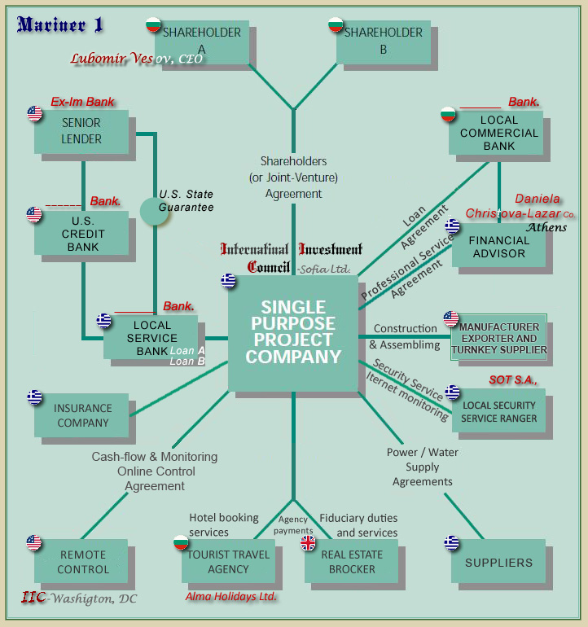

This presentation of Project Contracts here and in addendum allows the lenders to “step into the shoes” of the project equity partners and take control over the project, its assets and its operation.





3 CERTIFICATE [⮉](#Content2" \o "back to CONTENT)

WE, INTERNATIONAL INVESTMENT COUNCIL, Washington, D.C., hereby certify that the above Executive Summary and the related Business Plan – Cash-flow Pro-forma Budgeting with Sensitivity Analyzes, Profitability and Risk Assessment, the whole financial model – are beneficial to the project, originated and is made in Greece by a local entity. We also confirm that without these products and the comprehensive Feasibility Study made by the Advisor this project would not be possible.

SIGNATURE:

_______________

Date:

4 [PHOTO AND DRAWING GALLERY](BizPlanKM_Encl.docx) *(*[*attachment*](BizPlanKM_Encl.docx)*)* [](BizPlanKM_Encl.docx)



LIST OF ENCLOSURES[24] ⮉

1. To be determined after receipt of the engineering offer from manufacturer / exporter of the capital goods and services
2. **⮝**

   Certificate of Incorporation 
3. This Summary contains [interactive](http://www.businessdictionary.com/definition/interactive.html) [link](http://www.businessdictionary.com/definition/hyperlink.html)s to hypertext and graphical [element](http://www.businessdictionary.com/definition/element.html)s, and cross-reference links to this or various [electronic document](http://www.businessdictionary.com/definition/electronic-document.html)s herewith enclosed.
4. Letters of intent . . . . . . . . .
5. Functional Model of Capital-budgeting—Cash-flow Pro-forma and Analyzes*[](http://www.iic-london.co.uk/Mriner/Property/MarinerRO.xlsm)*
6. Risk Assessment and Management, Demo version [](http://www.iic-london.co.uk/Risk/RiskAssmnt_Demo.xlsm)
7. Handbook – Manual for operation with Risk Assessment
8. Risk Assessment and Management – brief description [](http://www.iic-london.co.uk/ctrl/projects/greenhouse/RA_Valister.xps)
9. . . . to be discussed . . .
10. International Investment Council, Athens
11. U.S. manufacturer - . . . to be discussed . . .
12. **Loan “A”** . . . **Loan “B”** . . .
13. . . . to be discussed . . .
14. The residual value is zero—long term of depreciation; rapid fall in prices of the PV-modules.
15. Advisory & Assistance Service and Software
16. Investment AAS Agreement
17. Online Cash-Flow Control System developed in 2003 by International Investment Council-Los Angeles and [University of California](http://www.universityofcalifornia.edu/), Prof. George Angelow, for remote operational control of cash out-lows in Internet, requiring solid business plan of the investment project (updated in 2013 in compliance with the effects of the recent financial crisis).
18. **Professional Service Cost Plus Fixed Fee (CPFF) Contract **
19. **Cash-flow & Monitoring Online Control Agreement** 
20. **Land Purchase Contract**
21. **Service Agreement for Permits and Regulations** 
22.
23. This block diagram and some explanations are borrowed from the [U.K. Department of Trade & Industry](http://en.wikipedia.org/wiki/Department_of_Trade_and_Industry_(United_Kingdom)) [](http://en.wikipedia.org/wiki/Department_of_Trade_and_Industry_(United_Kingdom)) , New & Renewable Energy Program; Guide for Developers.
24. Most of the listed names of documents are pending, not enclosed due to the pre-design stage of the Project, and are subject of further preparation.