4 PHOTO AND DRAWING GALLERY
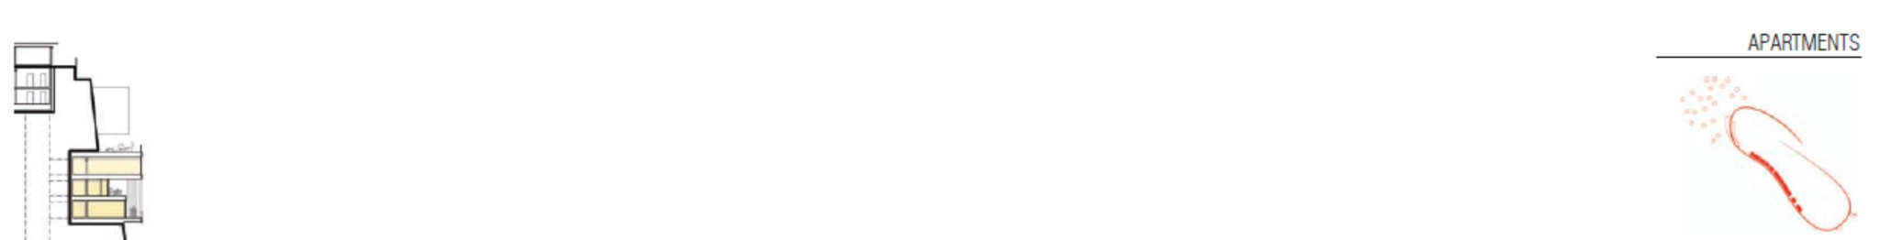
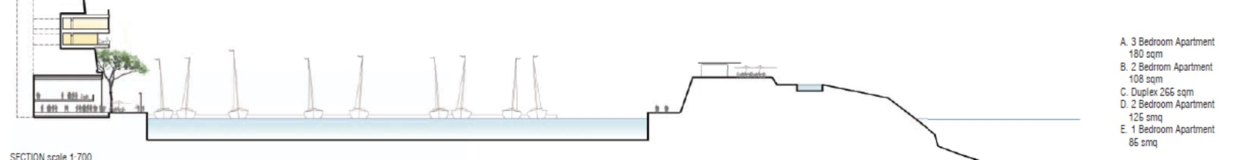
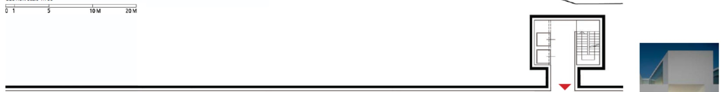
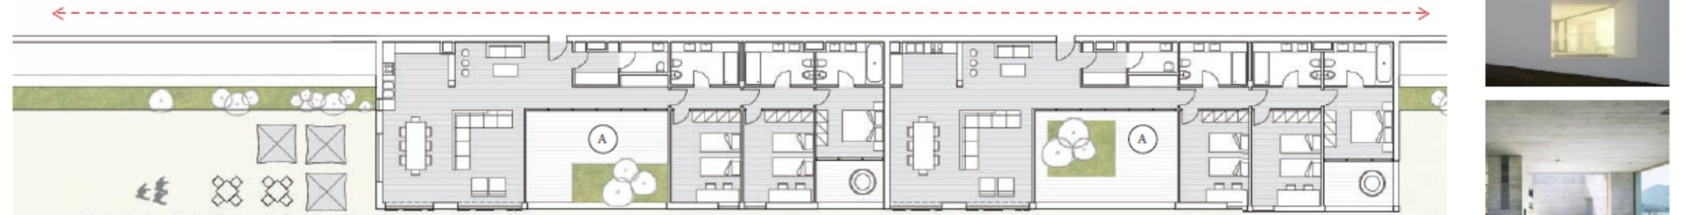
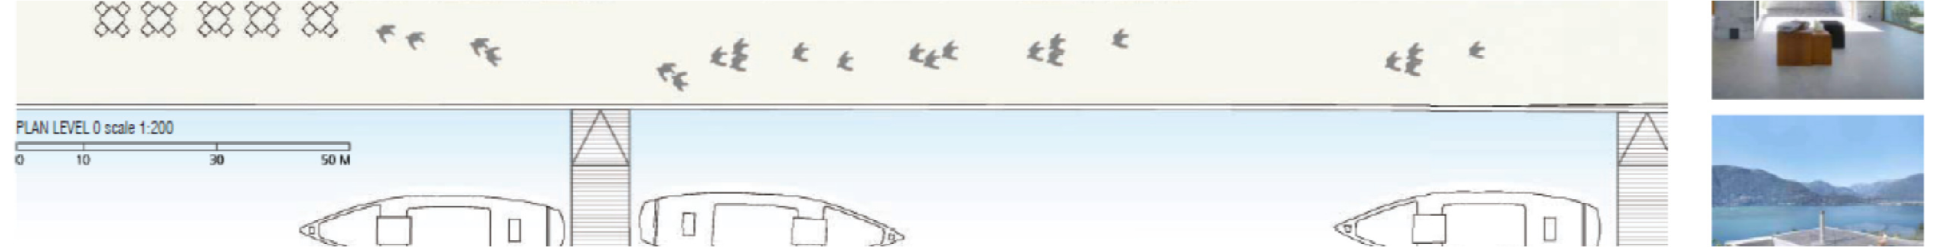
Project organisation structure
❶




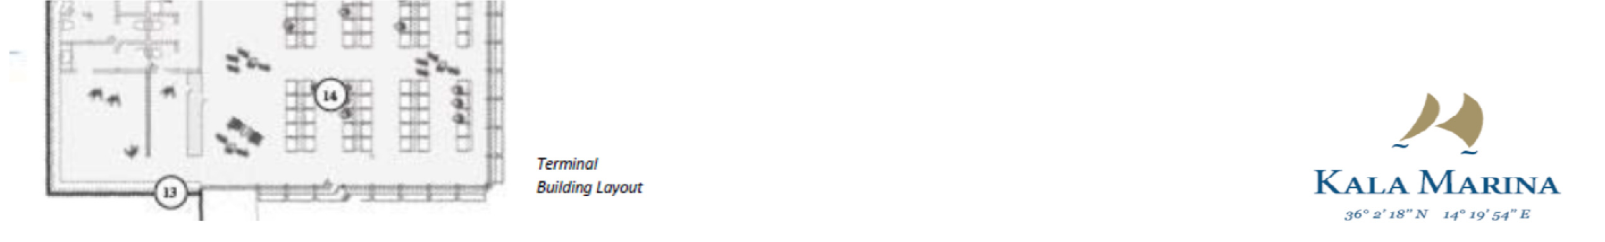
Project organisation structure
❷
Mediterranean Vacation Retreat

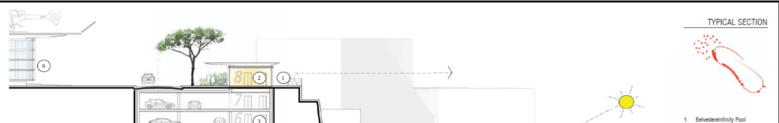


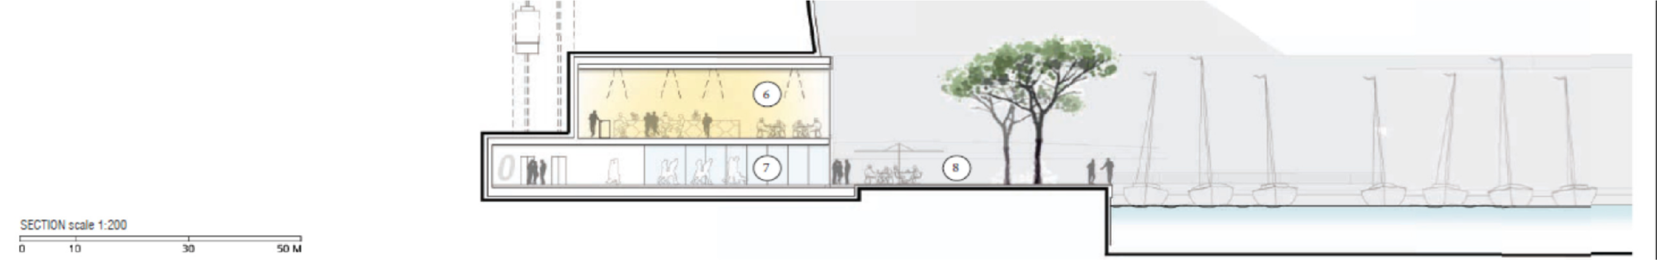
❸
Project organisation structure
Contemporary and Relaxed

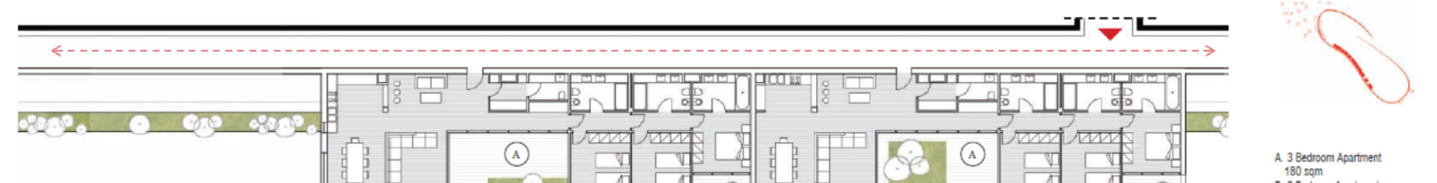
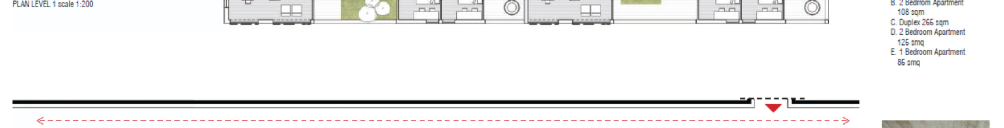
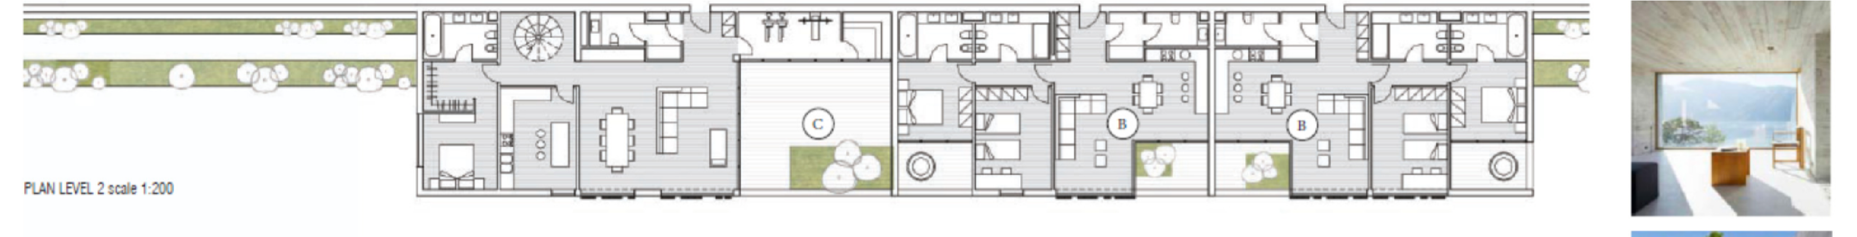
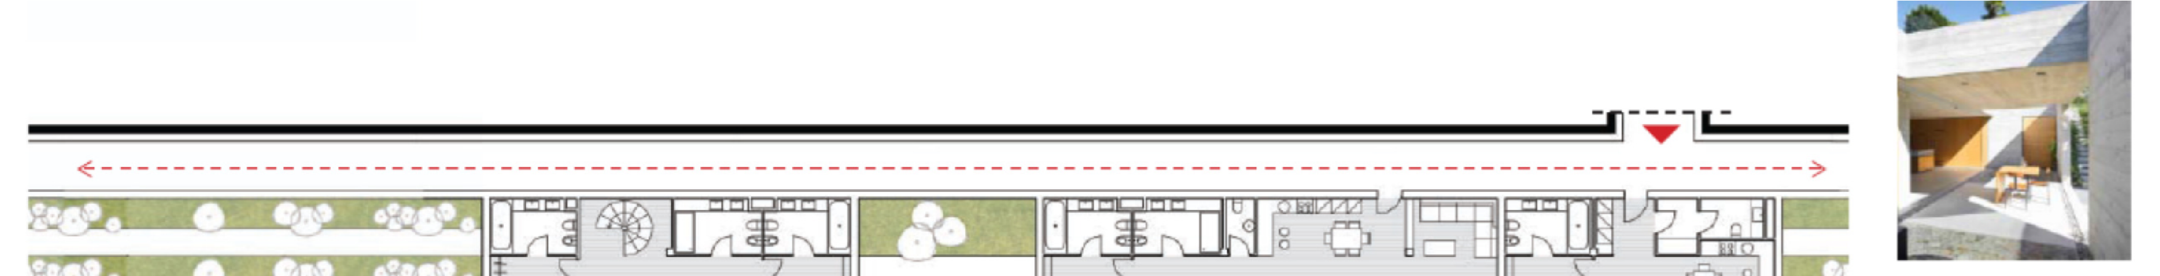
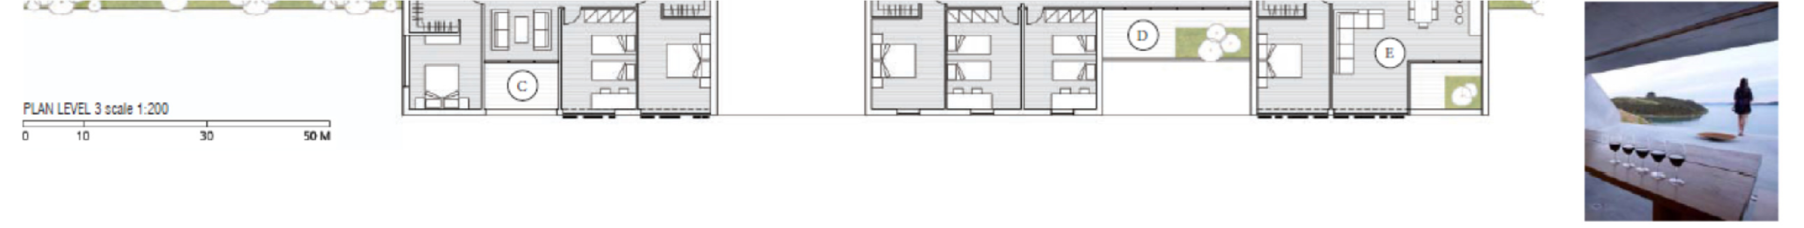
Project organisation structure

Two Bed Mediterranean

Contemporary

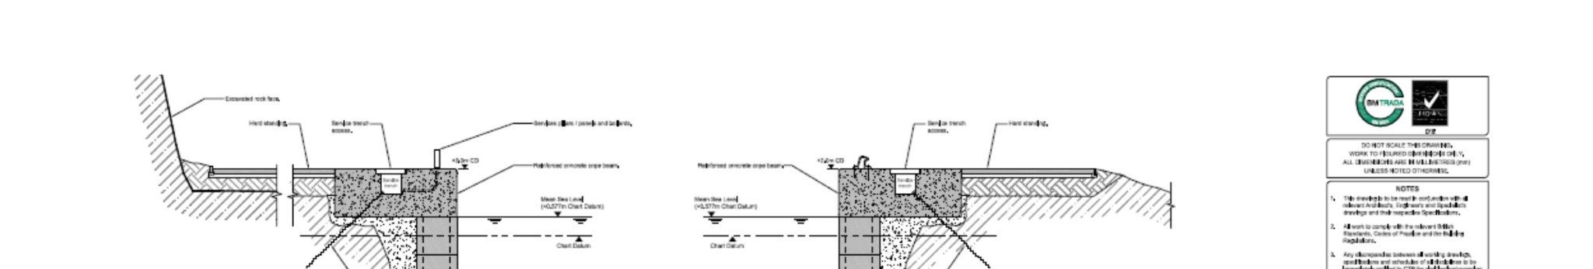

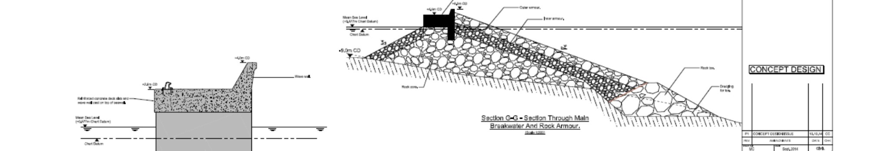
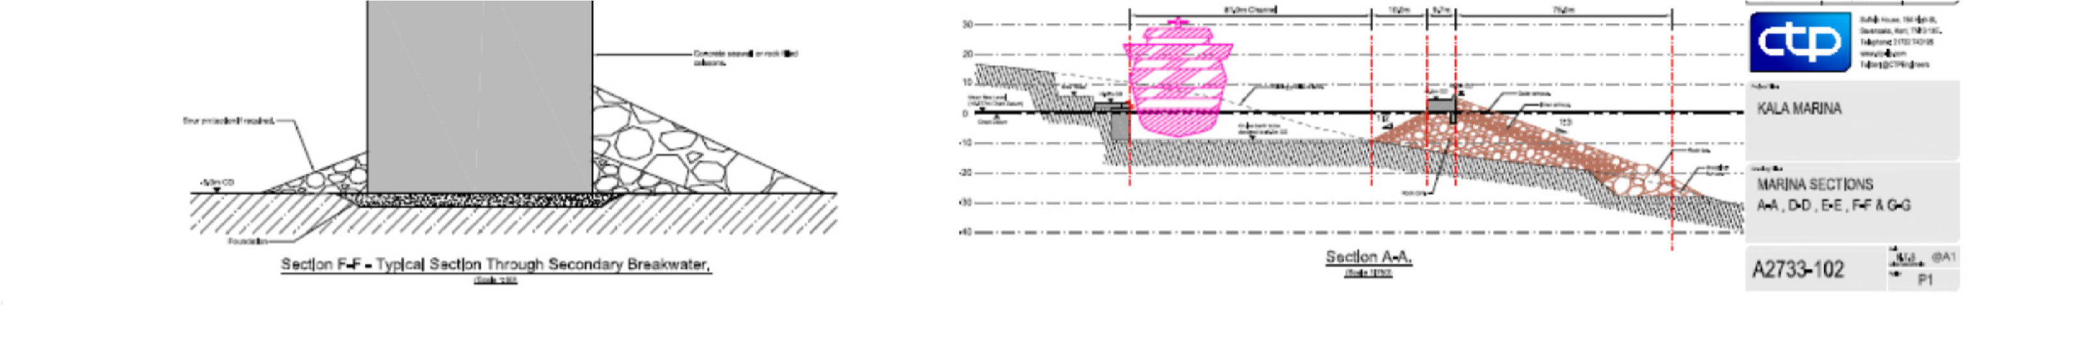
Project organisation structure

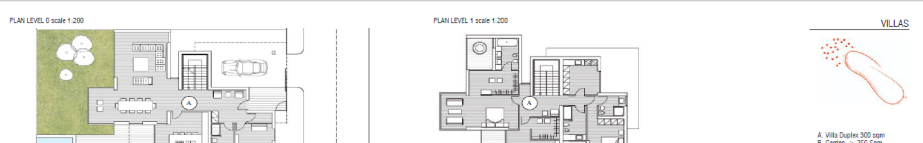
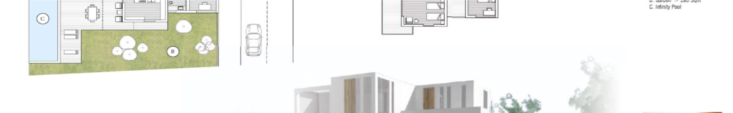
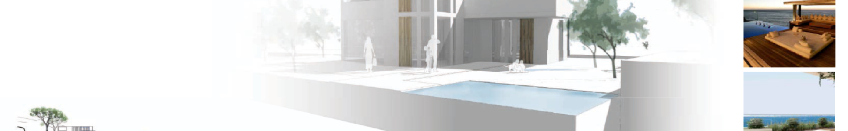
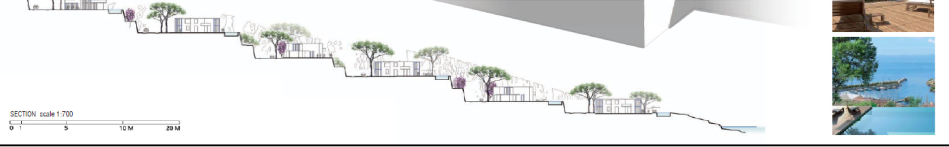
Project organisation structure

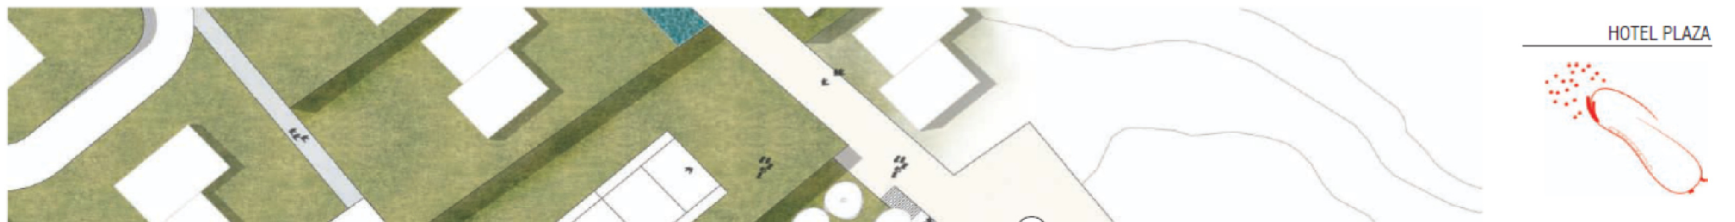
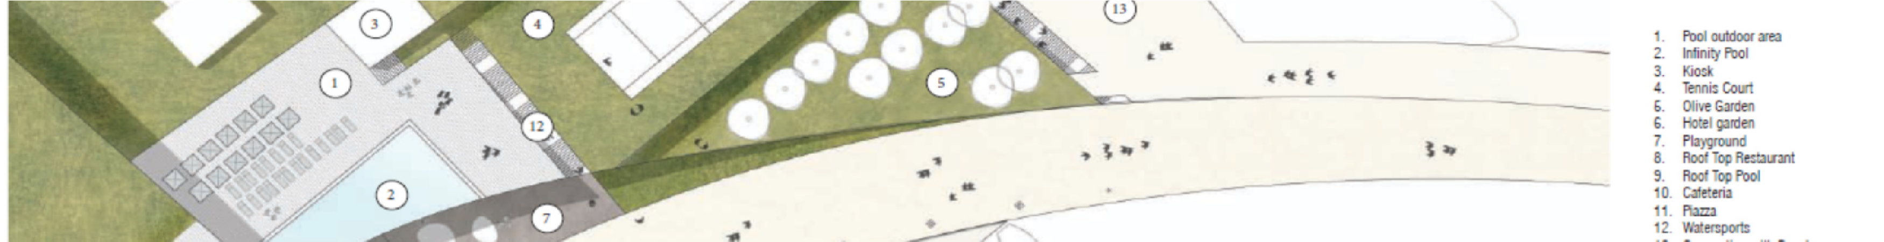
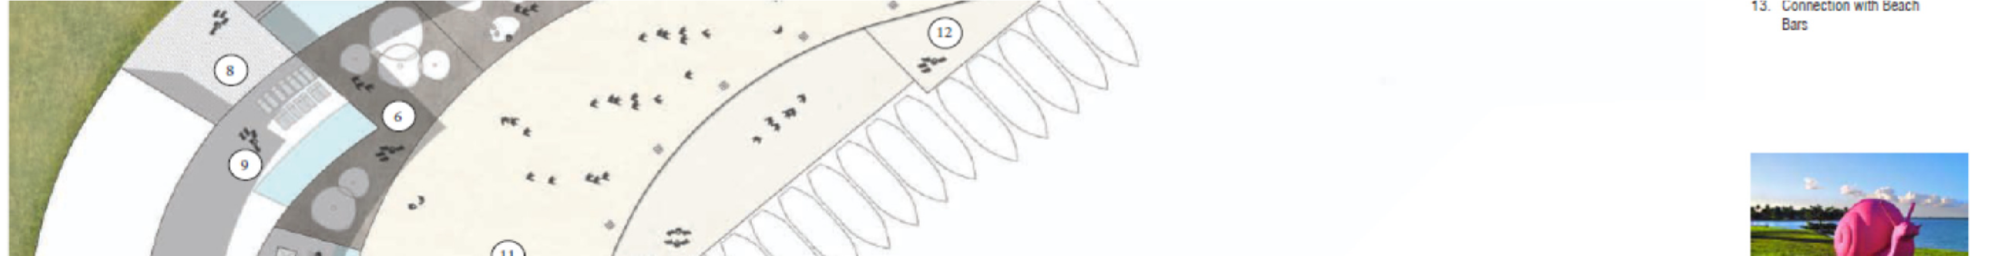
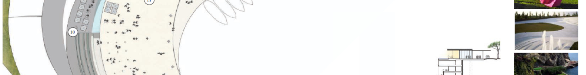
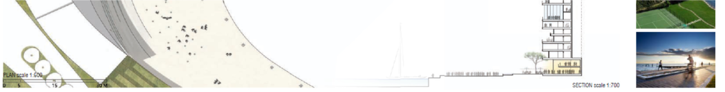
Project organisation structure



