D:\$_My WEBSITEs\__iic\ctrl\PROJECTS\RIPING\images\ArrDownMin.gif

**PREFABRICATED HOUSES AND HALLS**

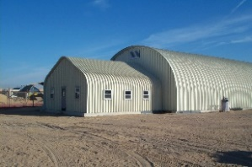General information

**Ultimate Building Machine**

**①** **First stage**:

1. Machine for the production of arched halls with a range of 15-30 meters.
2. [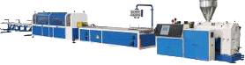](https://sino-tech.en.made-in-china.com/product/NngUFacyCLkl/China-Plastic-Sheet-Plate-Board-Film-Pipe-Profile-Floor-Trunk-3D-PVC-Wall-Panel-Vacuum-Forming-Machine-with-Low-Power-Consumption.html) Machine for the production of 3D panels for walls, roofs, doors, roofs and

thermal insulation.

1. 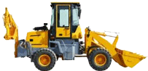Construction machinery.
2. Machine for production and laying of fire protection on

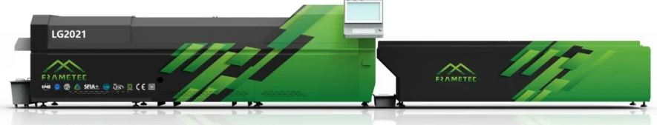polyurethane.

1. 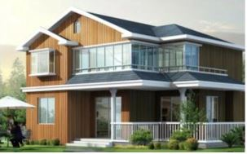Full automatic molding machine roll for   
   industrial halls and private houses. The machine

that makes buildings is an all-terrain, factory   
on wheels that produces durable steel buildings in days, not weeks or months.

[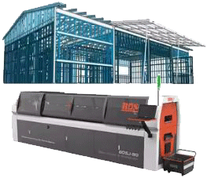](https://www.alibaba.com/product-detail/BOSJ-C89-Rapidly-Produce-Lightweight-Steel_1600687888299.html?spm=a2700.pcdrm.0.0.1a69C7oMC7oMCj)Easy to manage, she can to be transporteddirectly to any construction site via truck.

1. Production of building materials (walls and roofs) and tools for installation.

[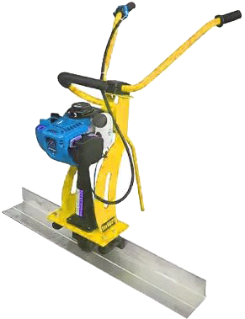](https://www.alibaba.com/product-detail/Factory-Custom-Laser-Vibrator-Leveling-Machine_1600966831381.html?spm=a2700.7724857.0.0.73d933a3P2p1tw)

1. 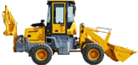Factory leveling machine with laser for fiber concrete screed   
   for production of light steel structures.
2. Double roll forming machine.

A small team of 10-12 workers can manufacture and assemble a   
structure from 3,000 sq.m. just for one day. They can be made and  
assembled in one day totally 20-40 houses of 40-60 sq. m.

**②** **Second stage**:

SELLER / SUPPLIER will provide engineering support for complete cold formed properties from steel structure up to 15th floor from where you pay for rigid frames the saving is between 15% to 40% compared to wood and concrete.

The wall studs and floor joists can be pre-punched for the penetration of electrical and plumbing pipes, saving project time and costs by another 10%.

Conventional low-rise wood-frame residential construction should be replaced with 100% non-combustible steel construction. All electrical service holes must be pre-drilled to accommodate and expedite electrical wiring.

These buildings require virtually no maintenance, as they are waterproof, rustproof, earthquake and fireproof. They have proven functionality in severe climatic conditions   
(heavy snow and typhoons).

**CONCLUSION** for the project company

This self-contained manufacturing factory on wheels is capable of manufacturing and assembling an entire building on the construction site. The high speed of construction and the patented panel stitching process allow a team of 10 to 12 workers to assemble a building in just one day.

Construction time is reduced as UBM steel buildings require no screws, bolts, fasteners, beams, trusses or columns.

It is expected buildings to cost 40 to 60 percent less than labor-intensive conventional construction. We expect the manufacturer/supplier's technology to reduce our costs by reducing manpower and by eliminating our dependence on architects or engineers. With the sewing machine, there is no need for nuts, bolts or screws.

This feasible solution allows us to construct a building in just one day, saving valuable time and money.

**ADVANTAGES** [**↑**back up](#F_1)

1. With the above equipment, a lower price than the wooden frame is guaranteed. The higher the structure, the greater the savings. For medium to tall structures, cost savings for rigid frames are between 20% to 50% compared to wood and concrete.
2. These structures are 20% lighter than wooden structures, saving starts from the foundation.
3. Wall studs and floor joists are pre-punched to penetrate electrical, plumbing and HVAC ducts, thus minimizing drop ceilings, soffits and all types of secondary framing, saving project time and cost, saving another 20%.
4. Compared to wood frame, pre-panel frame speeds up graphics by at least 50%, if not 75%.
5. All framing panels are made in parallel with the site work, resulting in a much faster completion of the project.
6. Conventional low-rise type V wood-frame residential construction can be replaced with 100% fireproof type II steel construction.
7. All electrical service holes are pre-drilled to accommodate and expedite electrical wiring.
8. 8. All plumbing horizontal and vertical passages in the structure are pre-designed and prepared for installation.
9. All HVAC (Heating, Ventilation and Air Conditioning) ducts and pipes can be installed not only parallel, but also perpendicular to the floor joists, thus eliminating drop ceilings and soffits, any type of secondary construction, improving room ceiling heights and significantly save construction cost.
10. The cost of building insurance for a frame is 1/5 of a wooden frame. Construction operations and maintenance costs for the structural part will be 1/10 that of the timber frame.
11. Such a building will provide building owners with a much higher final property value.
12. This construction meets high safety standards, including European CE compliance. The buildings require virtually no maintenance as they are waterproof, rustproof, earthquake and fireproof. They outperform most structures with their proven functionality in severe weather conditions (heavy snow and typhoons). A cost-effective solution, UBM simplifies construction.  
     [arrow2upback up](#F_1)