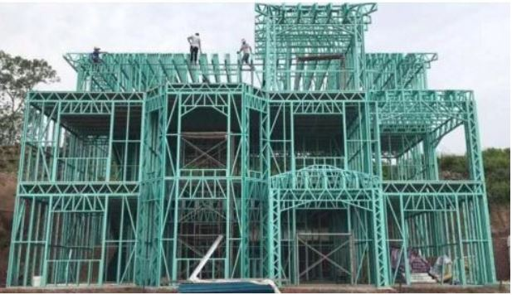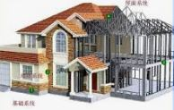

****

C:\Users\George\Documents\_iic\Jar\_GRAPH&PICT\iic_w_.gif **It has been modernized many times**

.

(Made by Boston, USA)

**PREFABRICATED HOUSES AND HALLS**

Manufacturers of building machine for **Building Materials** and Steel Structure Construction

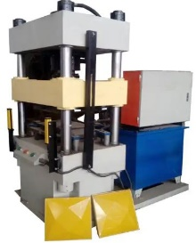Import of machinery and materials **Ultimate Building Machine**

1. **Building Material and Machinery 40-60m/Min High Speed G**

***Packing, domestic transport and port charge*: ↘**

**[](https://www.alibaba.com/product-detail/HAIDE-3d-decorative-wall-panel-making_60817092009.html?spm=a27aq.26127229.2512339620.32.56932ef5sMOKVV)1.1. 3d decorative wall panel machine trigger coil,** **1 – 2 sets** *$****385* $5,500**https://www.alibaba.com/product-detail/HAIDE-3d-decorative-wall-panel-X- Xmaking\_60817092009.html?spm=a27aq.26127229.2512339620.32.56932ef5sMOK

**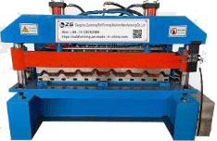**

* 1. **Metal Roofing Tiles Making Machine Glazed Tile Step   
     Metcoppo Tiles Wall Panel Press Step Metal Roofing** *$****1,120***

[](https://profileforming.en.made-in-china.com/product/uxqpVmDKvIkG/China-Manufacturing-Corrugated-Wave-Metal-Roof-Sheet-Wall-Panel-Tile-Making-Roll-Forming-Machine-Price.html) **$15,890   
Sheet Roll Forming Machine**

[https://profileforming.en.made-in-china.com/product/uxqpVmDKvIkG/China-Manufacturing-Corrugated-  
Wave-Metal-Roof-Sheet-Wall-Panel-Tile-Making-Roll-Forming-Machine-Price.htm](https://profileforming.en.made-in-china.com/product/uxqpVmDKvIkG/China-Manufacturing-Corrugated-Wave-Metal-Roof-Sheet-Wall-Panel-Tile-Making-Roll-Forming-Machine-Price.html)

**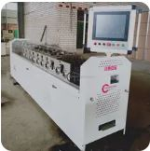**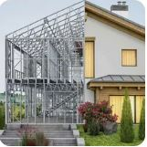

* 1. [](https://www.alibaba.com/product-detail/C89-Light-Steel-Keel-Villa-Making_1600129534830.html?spm=a2700.7735675.0.0.4201gvDRgvDRR8&s=p)**Light Steel Keel Villa Making Machinery Roll  
      Forming Machine For Steel House**

[https://www.alibaba.com/product-detail/C89-Light-Steel-Keel-Villa- Making\_1600129534830.html?spm=a2700.7735675.0.0.4201gvDRgvDRR8&s=p](https://www.alibaba.com/product-detail/C89-Light-Steel-Keel-Villa-%20Making_1600129534830.html?spm=a2700.7735675.0.0.4201gvDRgvDRR8&s=p)

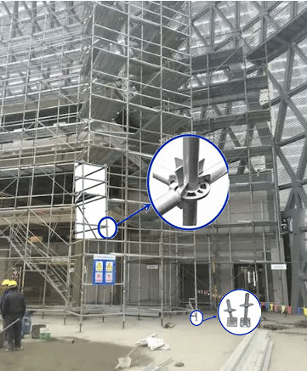

$**48,000** $**45,500**

**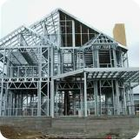**

*$****10,600***

$**58,000**

***SUB*TOTAL:**

CONSTRCTION MACHINERIES  
 and MATERIALS for

**MULTI-STORY BUILDINGS** *$****12,100*** $**173,000**

**HOUSES AND HALLS** ↓ FOLLOW ↓

MULTI-STORY BUILDINGS

1. **Building MACHINES AND MATERIALS FOR COLD FORMED STEEL**

**CONSTRUCTION OF BUILDINGS UP TO 15 FLOORS FRAME STRUCTURE**

**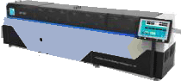**

***Packing, domestic transport and port charge*: ↓**

[](file:///C:\Users\georg\AppData\Roaming\Microsoft\Word\Full%20Automatic%20Steel%20Frame%20Machine%20for%20Galvanized%20Steel%20Frame%20Making%20Prefab%20House%20-%20China%20Steel%20Frame%20Machine%20and%20Frame%20Steel%20Machine%20(made-in-china.com))**2.1. Full Automatic Steel Frame Machine for galvanized   
steel frame making prefabricated House:**  *$****7,000*** $**100,000**

[Full Automatic Steel Frame Machine for Galvanized Steel Frame Making Prefab House – China  
Steel Frame Machine and Frame Steel Machine (made-in-china.com)](https://frametec.en.made-in-china.com/product/DOUaboHJJtWR/China-Full-Automatic-Steel-Frame-Machine-for-Galvanized-Steel-Frame-Making-Prefab-House.html)

* 1. 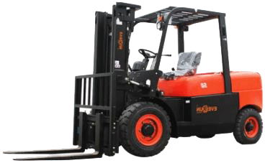[](https://everunequipment.en.made-in-china.com/product/veBnfcaogUHI/China-Low-Price-Everun-Erdf50-5ton-Portable-Diesel-All-Terrain-Forklift-with%20CE.html?from=edm&sendMail=bjjlKBghWV4y7534WV58CweDwbdhWV4ghk&utm_term=ai_express&utm_source=micedm&utm_medium=leadong&utm_campaign=CnQJoytuTmYP&utm_content=hQRmCnzEFxeV__IvLEqFOMcSXZ)**5ton Portable Diesel**

[https://everunequipment.en.made-in-china.com/product/veBnfcaogUHI/China-Low-Price-Everun-Erdf50-5ton-Portable-Diesel-All-Terrain-Forklift-with CE.html?from=edm&sendMail=bjjlKBghWV4y7534WV58CweDwbdhWV4ghk&utm\_term=ai\_express&utm\_source=micedm&utm\_medium=leadong&utm\_campaign=CnQJoytuTmYP&utm\_content=hQRmCnzEFxeV\_\_IvLEqFOMcSXZ](https://everunequipment.en.made-in-china.com/product/veBnfcaogUHI/China-Low-Price-Everun-Erdf50-5ton-Portable-Diesel-All-Terrain-Forklift-with%20CE.html?from=edm&sendMail=bjjlKBghWV4y7534WV58CweDwbdhWV4ghk&utm_term=ai_express&utm_source=micedm&utm_medium=leadong&utm_campaign=CnQJoytuTmYP&utm_content=hQRmCnzEFxeV__IvLEqFOMcSXZ)

*$****1,000*** $**14,600**

* 1. 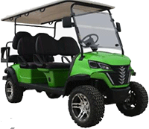[](https://dachiauto.en.made-in-china.com/product-list-1.html)**2.3. Dachi Electric 4+2 Seats Cart**

<https://dachiauto.en.made-in-china.com/product-list-1.html>

Electric. Power: 5000 W *$****280*** $**4,000**

* 1. **[](https://www.alibaba.com/product-detail/Light-Gauge-Steel-Frame-Rollforming-Machine_1600743836758.html?spm=a2700.details.0.0.23263048haU93b)[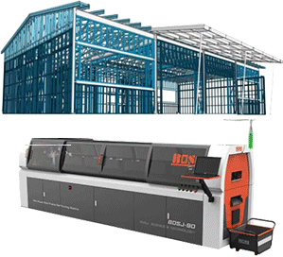](https://bosj.en.alibaba.com/index.html?spm=a2700.details.0.0.4d9f6d39E5d8r9&from=detail&productId=1600687888299)Light Gauge Steel Frame Roll-forming Machine   
     Roll Forming Machine Villa House Steel Frame**

https://www.alibaba.com/product-detail/Light-Gauge-Steel-Frame-Rollforming-Machine\_1600743836758.html?spm=a2700.details.0.0.23263048haU93b

*$****2,450*** $**35,000**

[](https://www.swllift.com/equipment/swllift-sj24li-telescopic-boom-lift-manufacturers-in-china/)….

* 1. **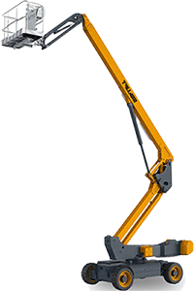Electric Telescopic boom lift**

https://www.swllift.com/equipment/swllift-sj24li-telescopic-boom-lift-manufacturers-in-china/

Load Capacity: 300 kg - 450 kg

Lifts - specifically designed to reach high points Unit Price: $**82,956**    
 in order to complete tasks quickly and safely. *$****5,800*** Max working height: 28.8 m

|  |
| --- |
| ***INFO*** *example: Offer prices: Machine:* $**82,956** *Packing, domestic transport and port charge*: $6,740  *CIF Rijeka port PRICE:* $90,981 |

Max operating radius: 22 m

Max. Platform Height: 24.2 m

Drive speed - stowed: 5.5 km/h

[](http://www.iic-london.co.uk/ctrl/PROJECTS/RIPING/Doc/Quotation%20of%20J26Li%20telescopic%20boom%20lift%20from%20swllift.pdf)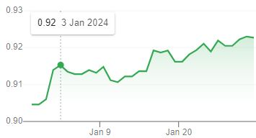 ↙ Ꞓ/$ ***SUB* TOTAL  
BUILDING MACHINERIES FOR UP TO   
15 FLORS HOUSES AND HALLS:** $**236,566** [www.swllift.com](http://www.swllift.com)

**TOTAL:** $**409,556.-** Ꞓ**376,800.-**