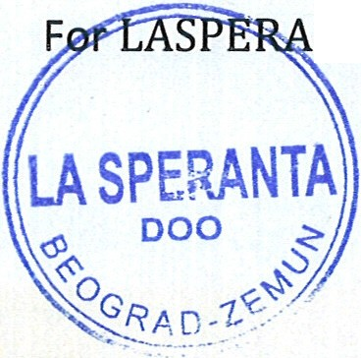
I | LASPERANTA 000  Belaricka 26c, Zemun, PIB: 11003411  e-mail: bbflex04@gmail.co m  November 28, 2019  KNOW ALL MEN BY THIS PRESENTS:  THAT L  the Chief Executive of this Company, based on the Contract # LC.33/317 of 10/23/2019 accept unanimous the following DECISION AUTHORIZATION :  Prof. George Angelow, PhD  as individual and  President of International Investment Council, Washington, D.C., U.S.A.,  is assigned and authorized as our TRUSTEE and CONTACT PERSON to contact, represent and negotiate with creditors, export credit agencies, lenders, investors, exporters of capital goods and services and prospective partners for development of capital investment project in Croatia -  SELF-SUPPORTING HALLS AND PREFABRICATED HOUSES  - for our industrial development. All they are invited to communicate the above.  Giving and granting into my Trustee these power and authority to do and perform all and every act and thing whatsoever requisite, necessary or appropriate to be done as fully to all intends and purposes as I might or could do if personally present, hereby ratifying all that our company lawfully do, or to be done by virtue of these presents.  I do hereby confirm To Whom It May Concern that I shall ratify by either words or conduct any lawful and reasonable agreement within the scope hereinabove laid out or otherwise is follow­ ing therefrom.  N WITNESS WHEREOF, I, Bosko Bezbradica, CEO of the licensed entity, executed this Deed as of the day and month first above written  NTA Ltd. \  (j '·  LASPERANTA, Ltd., 26c, Zemun, Serbia  mob. +381-628 482 126, e-mail: npegis@gmail.com

