



**_____________ S.p.a.**Lamezia Terme, Italy

**BUSINESS PLAN**

**Speedway Complex**

Executive Summary

June 2015

Executive Summary

|  |
| --- |
| **CONTENTS AT A GLANCE** |



**INFORMATION MEMORANDUM\***

[CONFIDENTIAL NOTE🞃](#Confident" \o "Confidentiality)

INTRODUCTION, Identification of Developer🞃 Location of the Project

PROJECT INFORMATION AND TECHNICAL MEMORANDUM🞃 Page

1. PROJECT SUMMARY 4
2. BRIEF DESCRIPTION
3. Type of Project
4. Author of Project
5. Purpose and Objectives
6. Scope of the Project
7. [PROJECT DEFINITION](#PD" \o "DEFINISAN) [5](#PD" \o "DEFINISAN)
8. FINANCIAL ANALYSES AND MODELING 6

* Level 0 Description of the business and input to the financial model
* Level 1 Costs of capital goods and services – loan principals
* Level 2
* Level 3

1. RISK ASSESSMENT AND MANAGEMENT 11
2. PHOTO GALLERY 16
3. LIST OF ENCLOSURES 14

**__________________**

**\***This Summary is generally assumed to be used online. TheURL links 🞃 and ⮉, etc. on the electronic copy facilitate following the content when read. References to external sources are intended for people who are using assistive technologies, and for non-financial experts—administrators, business managers, entrepreneurs, translators.

contact information

*e*mail: boston@iic-london.co.uk about this bizPlan: ph. +359-888-69 07 96 – Prof. Dr. George Angelow, advisor & authorized signatory[](http://www.iic-london.co.uk/partners/Avis/DoA_e.xps)

**CONFIDENTIAL** **NOTE**

This Business Plan (the present EXECUTIVE SUMMARY, Excel-based ***Pro-forma*** ***Capital-Budget­ing****,* Risk Assessment Program, the enclosed contracts, commercial offers, certificates and other papers and instruments) contains commercial and business secrets, and is **confidential and/or privileged**.

Electronic copies are not for re-direction. Hard copies of this Business Plan (Feasibility Study) are intended for named recipients only.

The information collected herein is based on intellectual property created by U.S. Company and must be held confidential subject to the Freedom of Information Act in Title 5, United States Code, Section 552, Privacy Act of 1974 (5 U.S.C. 552a), except as required to be disclosed pursuant to applicable law.

Copyright 2012, International Investment Council, Washington D.C. and [Prof. George Angelow](http://www.eec.us.com/resume_g.htm), President

*This is a Feasibility Study. It does not imply an offering of securities.*

*Prepared by East Electric Company, Ltd, Sofia, with courtesy   
of International Investment Council, Washington, D.C., U.S.A.*

**INTRODUCTION** ⮉

*THIS BUSINESS PLAN AND THE FINANCIAL PACKAGE COULD BE PERMANENTLY UPDATED TILL CONCLUSION OF THE CREDIT LOAN AGREEMENT*

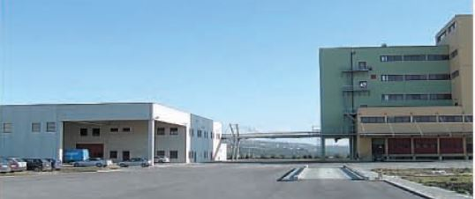[](http://www.exim.gov/products/loanguarantee/projectstructuredfinance/)**This Executive Summary** of the **Business Plan** is a part of the Financial Model for financing the investment project of **Molini Tandoi S.p.a.** (“Tandoi”) by the Export-Import Bank of the United States (Ex-Im Bank). Tandoi is prospective creditworthy borrower and buyer/importer of wheal and investor of capital goods from the U.S. for a remarkable investment program.

**Location of the Project**

Molini Tandoi S.p.a.

Viale della Palma n.8

Corato (Ba) 70033

Italy

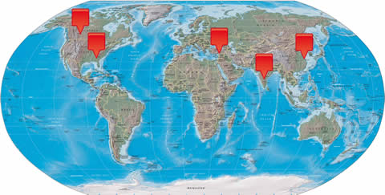[*info@tandoi.it*](mailto:info@tandoi.it)  
*Tel. 0039 / 80 / 3720611*  
*Partita Iva 02626450726  
Registro Imprese BARI nr. 02626450726 nr. REA 227980*

**Ownership & Shares**

Filippo Tandoi 42.5% 12,750

Adalberto Tandoi 42.5% 12,750

From raw material exports to finished products, our brands are present not only in Europe but also overseas, in the U.S., Canada and even in India, Middle East, Far East etc., undertaking established business relationship for years with world-class partners.

Elia Pellegrino 5% 1,500

Tandoi Srl 10% 3,000

**Total: 30,000**

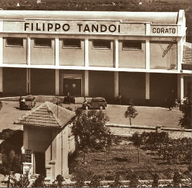**Tandoi** Group was established in far back 1908 and has since then developed and updated with the latest technology in the industry as the largest grain processing company in Italy and leading in this industry in the EU. It is owned by brothers Filippo & Adalberto Tandoi, CEO―today four mills and two pasta factories.

**Tandoi** works more than 300,000 tons of grain and 65,000 tons of highest quality pasta per year, and have over 200 employees. In these relatively hard for the European economy times the output of the company has new markets and plans to increase production. The present general parameters of Tandoi are:

Today capacity:

● 580 ton/day of wheat

● 435 ton/day of durum wheat

● 300 ton/day of pasta

Turnover:

● 2011: € 120,000,000.-

● 2012: € 65,000,000.-

● 2013: € 25,000,000.-

● 2014: € 10,000,000.-

The required new capital investments, subject of this project, are as follows:

● Prompt **import of high-quality raw materials\*** (especially high protein) which is not available in sufficient on the national market. The national production of wheat, tends, on average, to cover 55% of the needs of the durum wheat Industry milling and 40% of the needs of the soft wheat industry milling imports may therefore be regarded as complementary and not alternative to the national production ‒

- budgeted amount**$39,600,000**.-

- duration 12 months with option for prolongation (if the case so requires)

● Capital investment in new production facility:  
**Platform of cereal storage**\* of 16,000 tons to increase the storage capacity of the grain, save the cost of freight vessels for transportation and better exploit the production capacity of the mill –  
budgeted amount **$3,600,000**.-  
middle-term loan life of 6 years

● Capital investment in small renewable-energy project:   
**Photovoltaic power plant** of 1.5 MW* ‒ that meets Ex-Im Bank’s credit standards of Renewable Express Program ‒  
- budgeted amount **$1,680,000**.-  
- middle-term financing of 6.5 years.

The process of performance of the project creates conditions, fiscal and financial identification of a new credit practice, for reinvesting in the most profitable project. Construction of new plant for flours and pasta with hundred percent U.S. made equipment and Italian technology in a third country with potential big market is the ultimate goal of this business venture.

**PROJECT INFORMATION AND TECHNICAL MEMORANDUM** ⮉

 **.** PROJECT SUMMARY

* 1. BRIEF DESCRIPTION

1. Type of project

This is a typical [capital investment](http://www.businessdictionary.com/definition/capital-investment.html) in a [six sigma project](http://www.businessdictionary.com/definition/Six-Sigma-project.html) developed by a big creditworthy company with the ancillary services provided on “arms-length” bases by financial advisory of East Electric Company Ltd. with support and permanent monitoring of the specially created for this purpose Partnership “International Investment Council – Italy” (the “Partnership”).

The project consists of four parts. For easier perception of its structure, the stages of its development are presented on the principle of cybernetic―the hierarchical structure:

* The basic *zero level* is quality wheat and other components exported from the United States and delivered to the neighbor host country port Bari, less than 24 miles from Tandoi. This resolves the problem with the short-term working capital which Tandoi recently experiences. It is applied **Export Credit Insurance** Program of Ex-In Bank. U.S. producer/exporter increases his export sales by limiting his risk, offering credit to Tandoi collateralized by Ex-In Bank. Thus the exporter reduces nonpayment risk, increases cash flow, etc.
* Next *first* *level*, created on the previous one, is capital investment in platform of cereal storage of the imported raw materials. It is subject of **Structured Finance** Program of Ex-In Bank. Financing of this level depends on Tandoi‘s creditworthiness as reflect on the balance sheet and other sources of collateral or security enhancements through comprehensive business plan and solid financial model of the business venture.
* The next *second level* of the pyramid is the highest level of capital investment―the last innovative technology of green energy―photovoltaic park which will power the whole Tandoi‘s plant, which is released from the national electricity grid of the Italian government suppler Enel, delivering one of the most expensive energy in the EU;
* The *top level* is constriction of new plant for production of flours and pasta with hundred percent U.S. made equipment by newly established Tandoi‘s Project Company overseas under the Ex-Im Bank **Project Finance** Program.

This concept requires an extremely high level of financial risk assessment. It will be made and further managed in compliance with and by online cash-flow control system.

1. Purpose and objectives

The main purpose of this project is to create conditions for development of the Company through credit financing to stabilize production and expand the market with construction of new modern factory in a favorable market environment.

1. Description of the location where the project is implemented

* The national production of wheat, tends, on average, to cover 55% of the needs of the durum wheat Industry milling and 40% of the needs of the soft wheat industry milling.
* The use of raw material procured in the Community or from third countries is attributable to factors of both a quantitative and qualitative view of the need for high-quality raw materials (especially high protein) is not available in sufficient on the national market.
* Imports may therefore be regarded as complementary and not alternative to the national production.

Tandoi was developed with the aim to produce and commercialize in South Italy flour, semolina, and by-products of the milling of soft and durum wheat.

The manufacturing plant is located in Corato (BA) with production capacity of:

* 1. About 114.000 ton/par Year of flour,
  2. About 86.500 ton/par Year of semolina,
  3. About 67.800 ton/ par Year of by-products of milling.

1. Market description

The national production of wheat, tends, on average, to cover 55% of the needs of the durum wheat Industry milling and 40% of the needs of the soft wheat industry milling.

Uses of Wheat in the Milling Industry

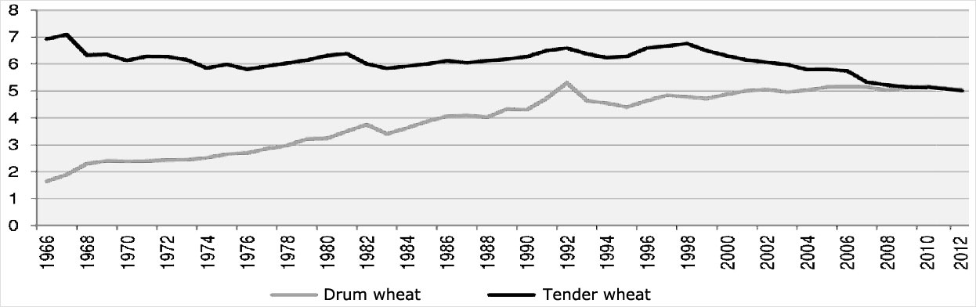

*Sales strategy*. The business expansion will lead by 2017 to fully exploit the productive potential of the mill;

* Semolina: supply agreements will allow us to offer and sell from 2016 already 100% of the production of durum;
* Flour: recovery of the channel customers craft allows in 2016 to operate the mill to 60% of production capacity; by 2016 sales growth also in the industrial and retail channel allow you to take full advantage of the productive potential of the mill.

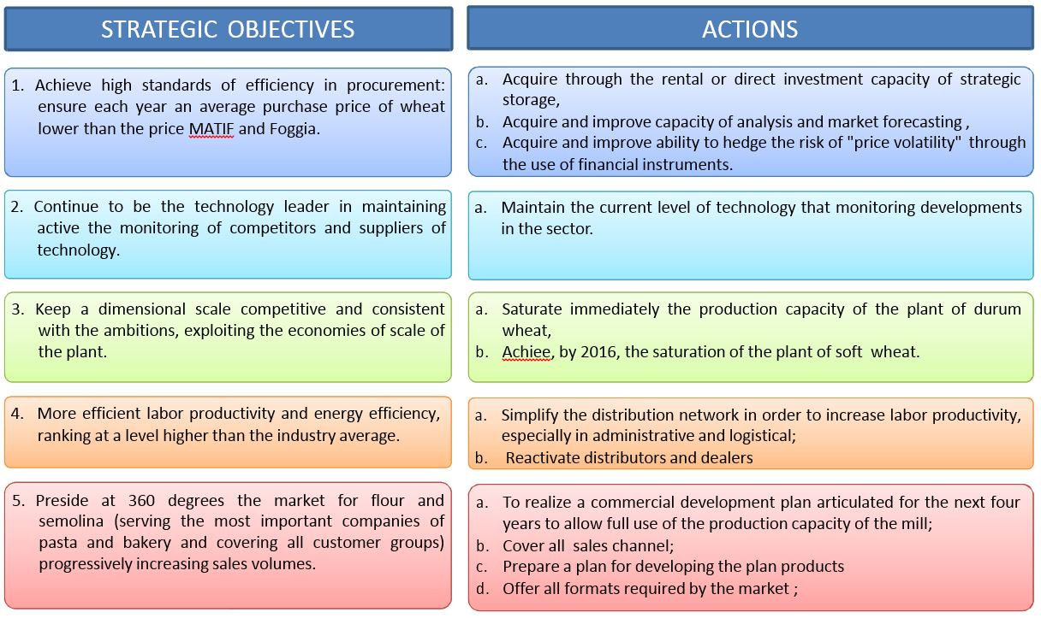

1. Authors of project

Tandoi requested[1] [International Investment Council](http://www.iic-london.co.uk/ctrl/content.htm), (“IIC”) to provide competent consulting on structuring of a stabilizing Tandoi Group program and to advice on how best to finance projects for its implementation in the current economic environment in the EU. IIC’s group of experts visited Tandoi’s milling plants, analyzed the financial and market indicators of investment strategy and agreed to develop a financial model with solid business-plan for the project in compliance with the Ex-In Bank credit policy.

IIC is DBA-formation with a total EIN of East Electric Company LLC, Washington, D.C. With resolution of its Advisory Board the requested ancillary services were redirected to the regional [auxiliary company](http://www.businessdictionary.com/definition/auxiliary-company.html) in EU, [East Electric Company](http://www.eec.us.com/INTRO_a.htm) Ltd., (“EEC”) for easier communication and for successful completion and operation, but all advisory work will be for the sole benefit of the Ex-Im Bank.

The above-mentioned analyzes definitely indicate the need of detailed quantitative assessment of financial risk and the choice of the **Export Credit Insurance** of Ex-Im Bank program puts this requirement as unconditional, combined with, management of the operational risk. It was resolved the authors of the project to use free the unique [IIC's software](http://iic-london.co.uk/ctrl/practice/fee.htm). To this end it was established the Partnership of three individuals―the author of the software and two Italian professionals.

1. Scope of the Financial Model of the Project

$558,200.- [Cell C11, Worksheet  **Budget** ]; capital investment loan (first stage) – three countries of distribution only, . . . . . .

The investment includes:

- . . . . . . - know-how, documents [Cell H40, Worksheet  **Cap.Goods** ];

- Software product for budgeting and online financial control full time of the loan life [Cell H40, Worksheet  **Cap.Goods** ];

- Reconciliation for permit to local country regulations with option for including other countries of the region [Cell H38, Worksheet  **Cap.Goods** ].

* 1. **PROJECT DEFINITION** **⮉**

This project was worked out to be presented to a credit institution for funding. The Financial Model of the Business Plan with Feasibility Study and Risk Assessment demo program file, compiled in two different Microsoft formats, all those supported by set of referring documents, will facilitate the auditors for a correct understanding.

Business Plan – Financial Modeling is made on an active Microsoft Excel.xlsm Workbook of 2007 Windows Office Package with exhaustive presentation in figures and math formulas of the business venture, as follows:

* Pre-Design Background in figures [Worksheet  **Intro** ];
* Capital Goods and Services with their prices [Worksheet  **Cap.Goods** ];
* Sales, Costs, Cash flows, Measuring Profitability and Pay-back methods applied, Sensitivity Analyzes, and graphical representations of most important parameters of the Project [Worksheet  **Budget** ];
* Personnel and salaries on payroll [Worksheet  **Staff** ];
* Decision Analyses of posterior probabilities of events affecting the most important factor with impact over the cash inflow for risk management in operation [Worksheet  **Bayes** ];

Business Plan – Executive Summary (this issue) where this Information Memorandum provides an attempt of verbal detailed descriptions of the project so as any auditor making due diligence to get full perception of the business venture with profitability evaluation, risks assessment for use of all participants in the credit transaction with full control of its performance and further operation. A reasonable part of the Summary is focused on guidance for friendly operation with the active program files and correct understanding of the contents of the whole Business Plan.

Risk Assessment and Management

* Excel-based software VBA-program file. It is provided in Demo Version with actual results of eight risk factor assessments and their impact over the business venture.**[2]**
* Detailed description of applied method.**[3]**

Handbook of the Professional-Full Version Program for Quantitative Risk Assessment.**[4]**

Supporting set of contracts and such other certificates, documents and other papers and information as the Credit Agency may request.





. FINANCIAL ANALYSES AND MODELING ⮉

Section 2 is the groundwork of the Financial Model by which the Business Plan of the project was developed.

The Financial Model is assigned to interpret the real business venture in figures and formal functional dependencies accomplishing a maximal isomorphism between them. The ultimate goal is an optimal control of the financial resource provided by the lender and/or investor - maximal profitability with minimum financial risk. To achieve those objectives it is expected the model to be formed in a hierarchical structure (pyramid), in this case of four stratification layers.

* Level 0

**The first layer** on the basic level is developed on [Worksheet  **Intro** ]. .. . . . . . ..

Example text & structure

↓

**Update** of this layer is possible, but once fixed we cannot change that basic stratification level or to create whatever on it anymore. It becomes something like hardware of the computing system. WHEN YOU WANT to examine the features of this model, your attention is focused to the next upper analytical layers (Worksheet  **Cap.Goods**  and  **Budget** ), and they are entirely built up by symbols, figures, formulas, and rules including such that indicate how to modify that rules, exactly like [formal systems](http://en.wikipedia.org/wiki/Formal_system) of high level. For this purpose we do not need the information about the countries, quantities of products and prices, and it is temporary hidden beneath windows. WHEN WE WANT to use the model for work and management the system, the window will be open to the basic input information.

**The selection** of which country is to be invested in can be made by Option Button. This ActiveX Control was preferred instead of the usual button because it leaves visible trace of the last choice. Through it the field on its right is completed with the respective data about the selected country copied and transferred from the INPUT FIELD COST ONLY located below. To exclude any country just click its flag icon. (This sentence does not make any sense.

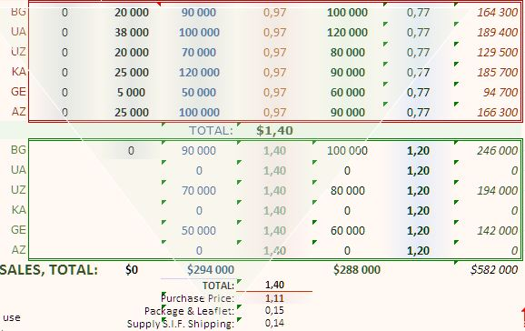**The** **mirror image** of the pyramid is the classic form of hierarchical structure model of a real object of control.

**The** **mirror pyramid** structure is inspired by four windows appearing consecutively the file is opened and it is prompted by a triangle of slight opacity. Its function is also to protect the main input data area of the project from hasty and half-backed changes of the figures in the area. You have to follow the INSTRUCTIONS FOR USERS on the right of the protected area.

**The designer** formulated the next upper levels of the model as formal systems and set buttons for visiting them. A friendly operation with the Financial Model and correct work of the VBA-program code of some macros, use the bottoms (not the sheet tags) when browsing in the workbook.

* Level1

**The rules** of operation of the formal system on Level 1 [Worksheet  **Cap.Goods** ] are determined by the rules of the upper Level 2 [Worksheet  **Budget** ], which in turn are defined by the functional rules of Level 3 [Worksheet  **Bayes** ]. The meta-rules of top-level cannot be changed because there is not a higher level over it, which has rules that specify how to modify these rules.

**This layer** contains the rules of the distribution of the borrowed funds during the grace period. It is three six-month periods. Every country regulations requires not less than 6-month term for issue, some of them – up to 12 months. The start-up procedures are planned with one to two periods later in order to cover optimal financial formula and risk mitigation norm. Both products as herein above introduced are handled separately for more flexibility of management, monitoring and operational control of the cash flows.

* **70%** of the price of the export pharmaceutical products are U.S. origin and 30% is French import raw materials.( to be confirmed)
* 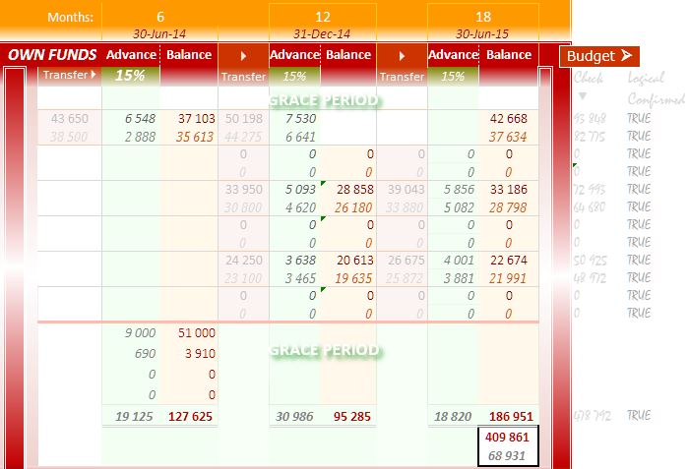 . . . . . . .the prices For **1**st **Yr**. trading period are presented here which are lesser than of the next years, when the respective markets will be better developed.
* For the basic country, Bulgaria, there is a pro-forma budget for covering of VAT which will help . . . . . .for immediate release the goods through the customs; repayment is automatically within one-week legal term by the country budget and later covered by the importer with the payment of the sold goods.
* The distribution of the payments – total amounts for each product on one hand and 15% own cash front payments and the balances on the other hands are math-logically checked (as algebrasums) and confirmed (by if-function) to avoid any mistake that could have been made in permanent operation with the figures on that and the next upper layers.
* 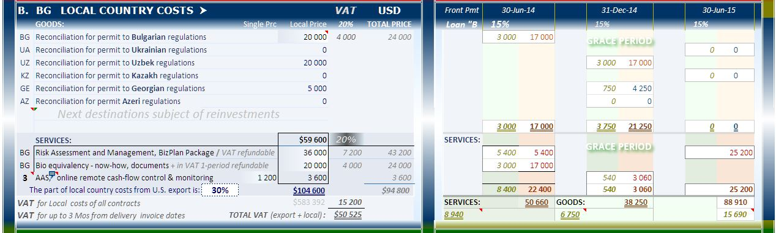The LOCAL COUNTRY COSTS pro-forma budgeting are distributed also within the same three grace periods.
* The amount of local country costs is **30%** of the total U.S. export value.
* Three services of critical importance for the project: (i) Risk Assessment and Management as a part of the Business Plan package, (ii) Bio equivalency - know-how documentation, and (iii) the three-month operation and training with the online cash-flow control and monitoring software system totaling **$59,600**.- are the greatest achievements of the pre-design period.
* There are planned provisional annual interest percentages for Loan “A”– Ex-Im Bank guaranteed credit **4.2%**; Loan “B” financing of 15%-front payments borrowed from commercial bank **5.5%**; and Loan “VAT” from Bulgarian commercial bank **7.5%**.
* Level2

[Worksheet  **Budget** ] –

**A layer** that receives information from lower Level 1, exercising the same practice and formal functional dependencies, and totals the amounts for the three 6-month grace periods of both Loan “A” and *Loan “B”*. Their sum forms Total Debt [Cell C11] which actually is the Capital Investment [Cell C17] $558,200.-

**The subsequent** couples of 6-month periodsduring the loan life are isomorph structures of annual inputs for costs and sales transferred for all countries from the respective calls of Worksheet  **Intro**  and under its rules – the financial formulas for cash flows – this layer builds pro-forma budget of the project. However, as far as this is a new analytical level, it modifies the rules of lower levels. On Rows 126 down to 152 are created separate cash flows for every country and product, where the data for the first credit period for each country are pre-reduced to be adequate to the beginning of a new distribution on a new market. Then each subsequent period through the percentage inputs on Column C the initial values are respectively increased for five blue periods after the first one due to increasing coordination of the 4 P's of marketing and mitigated operational risk.

**With the computing** of the interest payments and principal installments of these [medium-term credit[](http://www.businessdictionary.com/definition/auxiliary-company.html)](http://www.exim.gov/products/exportcreditinsurance/mediumterm/) loans the following becomes possible:

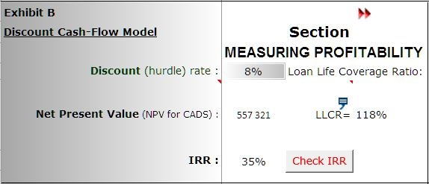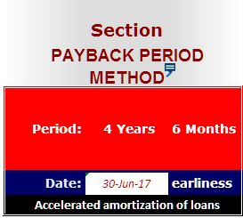

* Measuring profitability through the popular Discount Cash-Flow Models to recognize the time value of money and timing of the annual net cash inflows. Net Present Value (NPV) is applied to measure earning of revenues and measuring of receiving the premier asset, cash;

*and another model for capital budgeting Internal Rate of Return (IRR) which makes NPV equal to zero and that KEM can expect to earn by investing in the project:*

* NPV for CADS of the project is equal to 555,321 at discount rate 8% (cost of capital), C70.
* IRR is equal to 35% (click the Button Check IRR), C72

*And another model is Payback Period Method:*

* Payback Period is equal to 4 years and 6 months, H70 and I70. Loan “A” life is computed round down to 5 years, 10 six-month periods, and 18 months grace.

THE ABOVE IS A PESSIMISTIC FORECAST WHERE THE CALCULATION DOES NOT INCLUDTHE VALUES OF REINVESTING IN OTHER THREE COUNTRIES OF INTEREST.

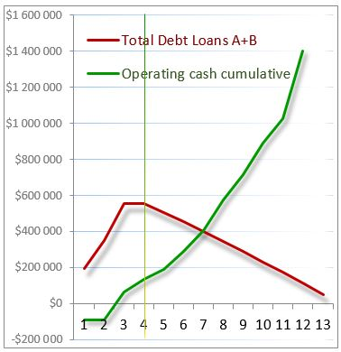Construct graphs of functions of total balance liabilities, cash flow, operating cash cumulative.

Sensitivity Analyses is a required attribute of the financial modeling of any investment project with low positive value of NPV because of the probability of one or more unpredictable events of interest on the market of the project to aggravate the cash inflow and the investor may not be able to repay the loan debt. About this project it is prescriptive only, to show the degree of impact of possible *bad* events over the cash inflow – when some agent does not achieve the expected results from his distribution compared with the basic country Bulgaria and has to be changed. This section will be developed for operational purposes on [Worksheet [**Bayes**](http://www.iic-london.co.uk/Mariner/Property/Mariner1-2.xlsm#Budget!B59)].

In this case: The default maximum score for ***good*** *event* of 95% for distribution in Bulgaria by Agent 1 is compared with overall probability to happen pessimistic one, ***bad*** *event*, equal to 60%; the percentage of Agent 1’s quantity of the total of both market is 64%. With this data in Bayes theorem is calculated Overall Probability of happening of a ***bad*** event equal to 17.60 [Cell P19, Worksheet [**Bayes**](http://www.iic-london.co.uk/Mariner/Property/Mariner1-2.xlsm#Budget!B59)]. Following the logic of hierarchical structure of the model, this correction factor descends to the lower value of Agent 2’s country sales on Level 2, [Rows 131 and 140, Worksheet [**Budget**](http://www.iic-london.co.uk/Mariner/Property/Mariner1-2.xlsm#Budget!B59)]. This amending external disturbance of *bad* event ratio acts as a feedback on the same level as reducing the value of sales. More about the application of this method will be found in RISK ASSESSMENT AND MANAGEMENT , which is an application to the next Section 3.



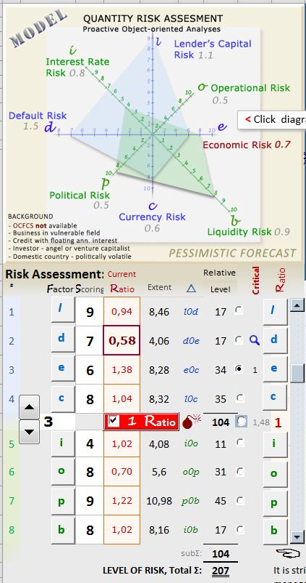 . RISK ASSESSMENT AND MANAGEMENT ⮉

* Level3 ***Top level.*** [Worksheet  **Bayes** ]

Brief Description of the Product *(The full description is subject of another issue)*

This is a pre-design assessment. Once the final parameters of the capital investments are available, a full version of the program will be provided for management of the risk during the loan life.

In the Main Operation Matrix (MOM) the assessor enters data which are based on general accepted criteria for quantity assessment in percentage of adequacy on the scale up to 10, applied and processed by the software product. The program is based on Excel-file of Microsoft Office 2007 package of Windows 7 with macros and algorithm of VBA-program language. This program is widely used in the U.S. and Britain after the failure of conventional products for risk assessment before the mortgage financial meltdown in 2008. A Demo-Version  and excerpt of with Handbook *[](http://www.iic-london.co.uk/Risk/HANDBOOK.docx)* for use and Presentation *[](http://www.iic-london.co.uk/Risk/RM_Description_Hi.docx)* of the product for quantitative risk assessment before investment and subsequent control over the debt period. Sensitive analyses are focused primarily (but not exclusively) on two risk factors, (d) and (o) of particular importance for financing and insurance institutions and, of course, to conceptually associated investor / borrower.

The figure to the left presents the introductory segment of MOM of expertise in a mathematical model of geometric figures, proportional to the size of the risk factors and the extent of its impact on the investment project.

Main Operating Matrix

Risk Factors

AssessmentRateLevel on 0-10 of impactof Factor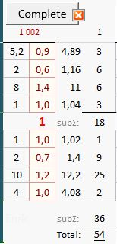

Number of assessors

Button to enter data of the assessor with **code index 1 002**

Value of the Factor multiplied the Rate of impact – this is the real level of this risk in the business environment.

**Coefficients** < 1 indexing subsequent strong impact of the risk management.

Risk assessment

Area of △ *p0b* = 12.2 x 4.08 / 2 rounded to 25 (see the figure)

Total area - **Total assessment**

Risk assessment with its impact over the business of KEM was made by one only ? external for expert for three trading destination countries – Bulgaria, Uzbekistan and Georgia. Code index **1 002** of this expert begins with **1**, which means that the above sub-matrix is from the first row of matrixes (Group “A”) of the Worksheet [**Bu**](http://www.iic-london.co.uk/Mariner/Property/Mariner1-2.xlsm#Budget!B59)**l**  (from the program file) and **002** – that the results are on a sub-matrix that is the second one after the Operating Form , which receives data from the MOM and transmits them to the sub-matrix by pressing the Button “Complete”. The buttons “Close” are to clean up the data. Rows 2 to 4 (Group “B” to “D” are with restricted access in the Demo-version as leg of necessity of their use for the purposes of demonstration of the method and program.

The numerical difference between the two matrices shown in the above figures are attributable to the following. The estimates in the MOM of the first figure are completed by the program automatically when the practitioner launches the program online. Those are values ​​equal to the average for similar projects completed in all previous analyzes by online users with licensed acquired working (not demo) versions (no indication of its origin). Data are stored in the home server and automatically update the respective cells. The difference between the average statistical risk assessments in such a business for which these factors are examined to date (Total: 204), and those of . . . . . . . (Total: 54) – about four times - shows that even before the beginning of the investment period the project . . . . . . . is in an acceptable form.

Low preliminary and incomplete risk indicators of . . . . . . . are estimates and considerable extent due to the intended OCFCS-condition (Online Cash-Flow Control System) flashover it is fulfilled and therefore: (i) . . . . . . . . has a valid contract for such control to the date of the last payment on the loan; and (ii) the funding institution (lender or investor) have permanent real operational monitoring and right of control. This means (not shown on the demo) that apparent from the *Presentation of the program product [](http://www.iic-london.co.uk/Risk/RM_Description_Hi.docx)*, the base of the pyramid, which as mentioned above of the assessed risk factors after each event of operational risk management, its area will be reduced, i.e. will reduce the risk in a statistically insignificant average of 0.5 (5%), which is assumed in the range of the error of "measurement".

In this analysis, the impact / management personality of decision making managers in the demo are not shown. When required, it could be made fully assessed risk analysis and complementary recommendations to management through the business/action plan during the debt period of the investment project.

Online Management of Cash-Flows and Risk Management

Mentioned in the previous paragraph OCFCS-system periodically (weekly, monthly, etc.) makes monitoring of the financial accounts, primary documents and returns, and adds the relevant figures in an active Excel-file. This is a program file - an expanded version of the Financial Model (business/action plan) - maintaining on the Website. The graphical representation of the planned and implemented indicators presents the difference (if any) and allows the user to monitor the assumed financial position of the debtor online as well as remotely from the program to require those primary accounting documents, which are due the found difference. This option significantly increases the credit worthiness of . . . . . .





. PHOTO GALLERY ⮉

**MAP OF REGION OF ORGANIZED DISTRIBUTION OF**

**OTC PHARMACEUTICAL PRODUCTS**

**Back to text**



 / LIST OF ENCLOSURES ⮉

1. Letter of April 1st, 2014 to IIC – request by Tandoi for financial advisory about financing capital investment project to stabilize and development the Company
2. . Risk Assessment 
3. . Risk Assessment and Management 
4. . Handbook of Program for Quantity Risk Assessment 

   17.

   The End

   